*************VPC, Subnets, IGWY and Route Tables setup steps***************

**Step#1**

Login to AWS Console and search for VPC

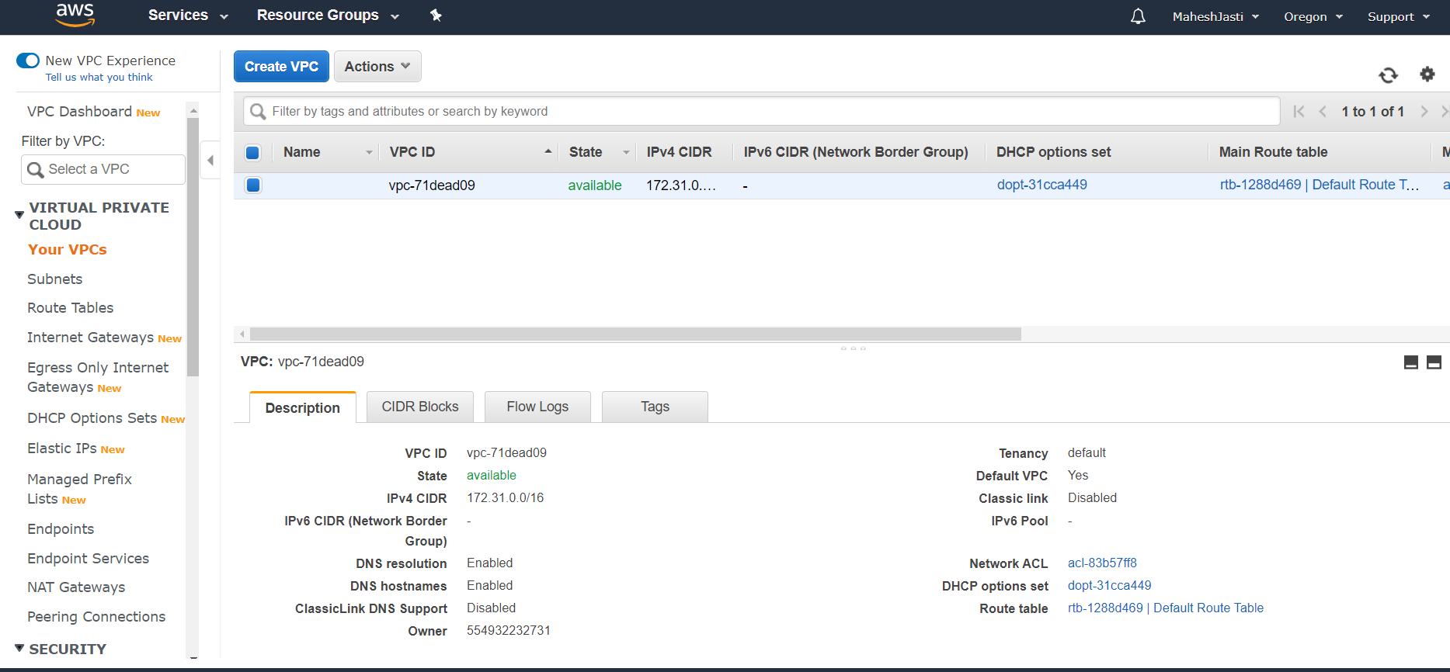

**Step#2**

Click on Create VPC button and enter the respective details

Nametag: ProjectMattermost ; CIDR Block: 10.30.0.0/16

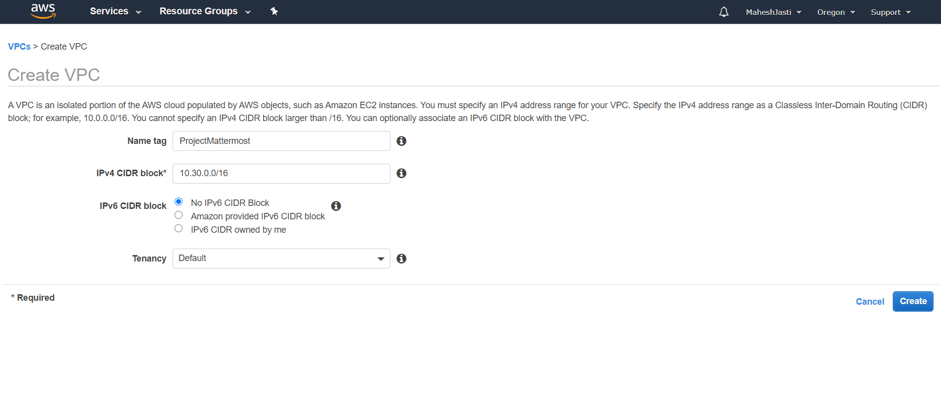

**Step#3**

Once click on create, it creates a VPC ID in the main window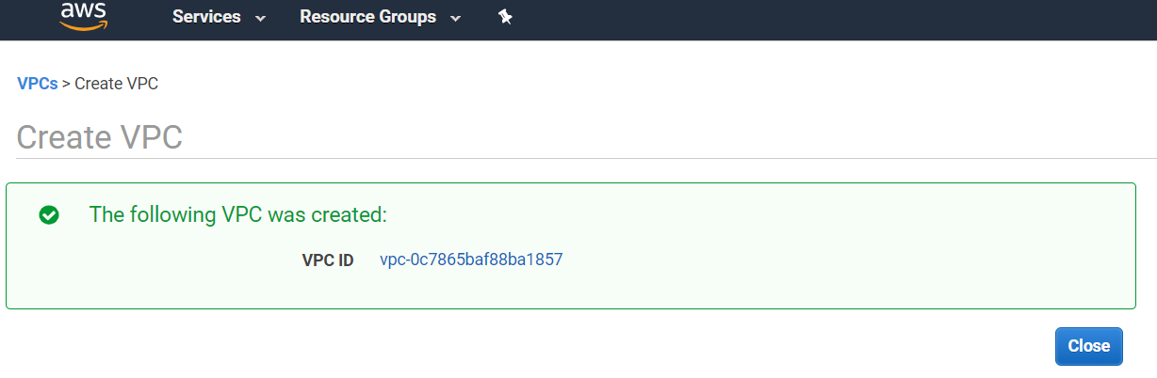

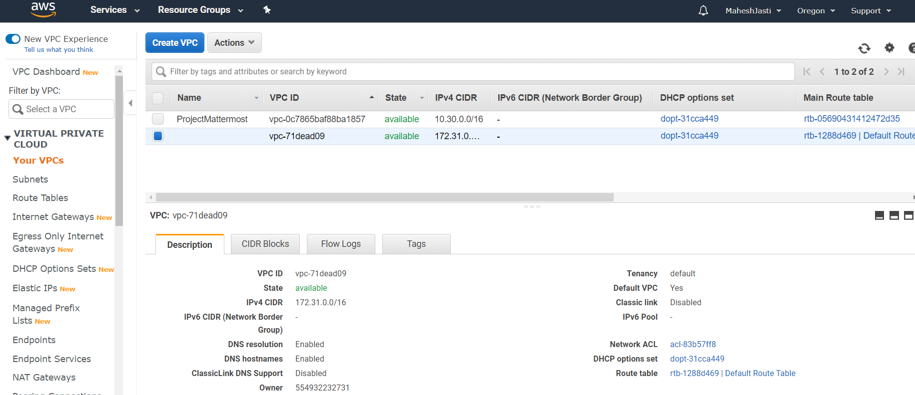

**Step#4**

Now after creating the VPC, click on the Subnets option on the left menu..

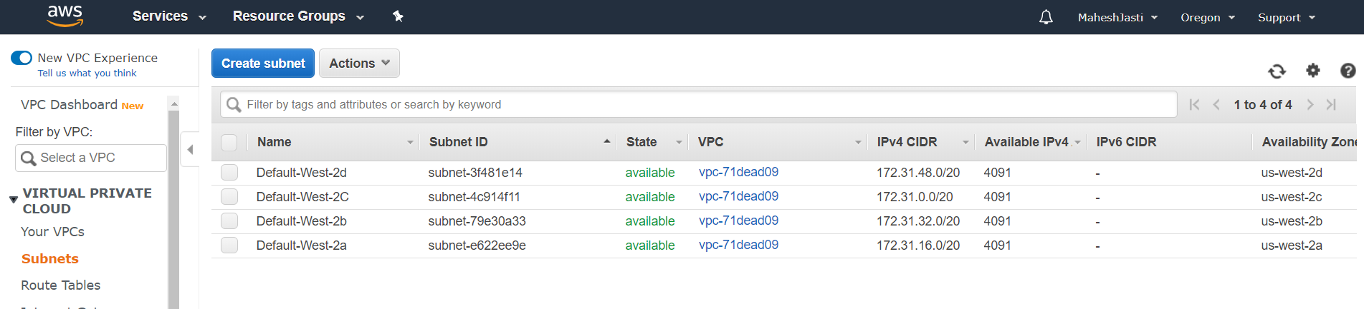

**Step#5**

Click on “Create subnet” blue button and create a Subnets as shown below.

**Subnet#1** – PublicSubnet with CIDR addr as 10.30.1.0/24 under us-west-2a

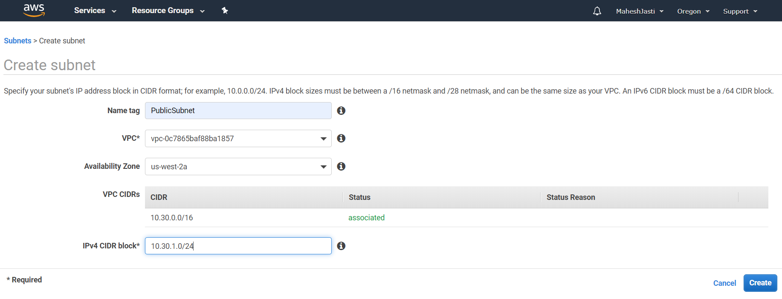

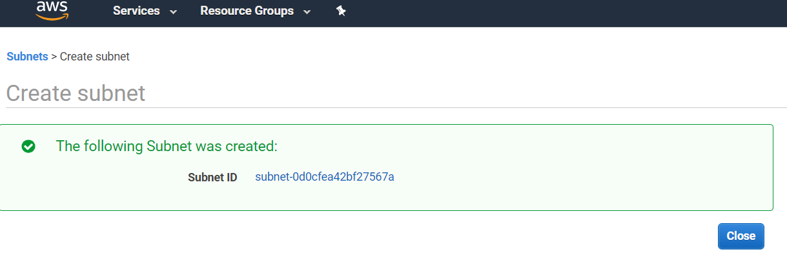

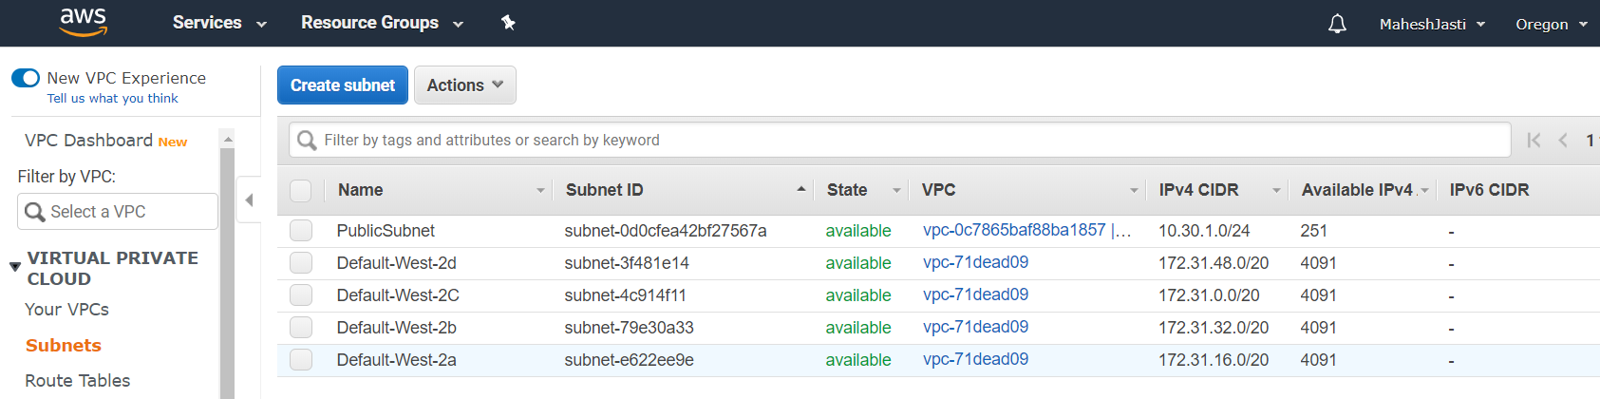

**Step#6**

Subnet#2 – PrivateSubnet

CIDR: 10.30.2.0/24 under us-west-2c

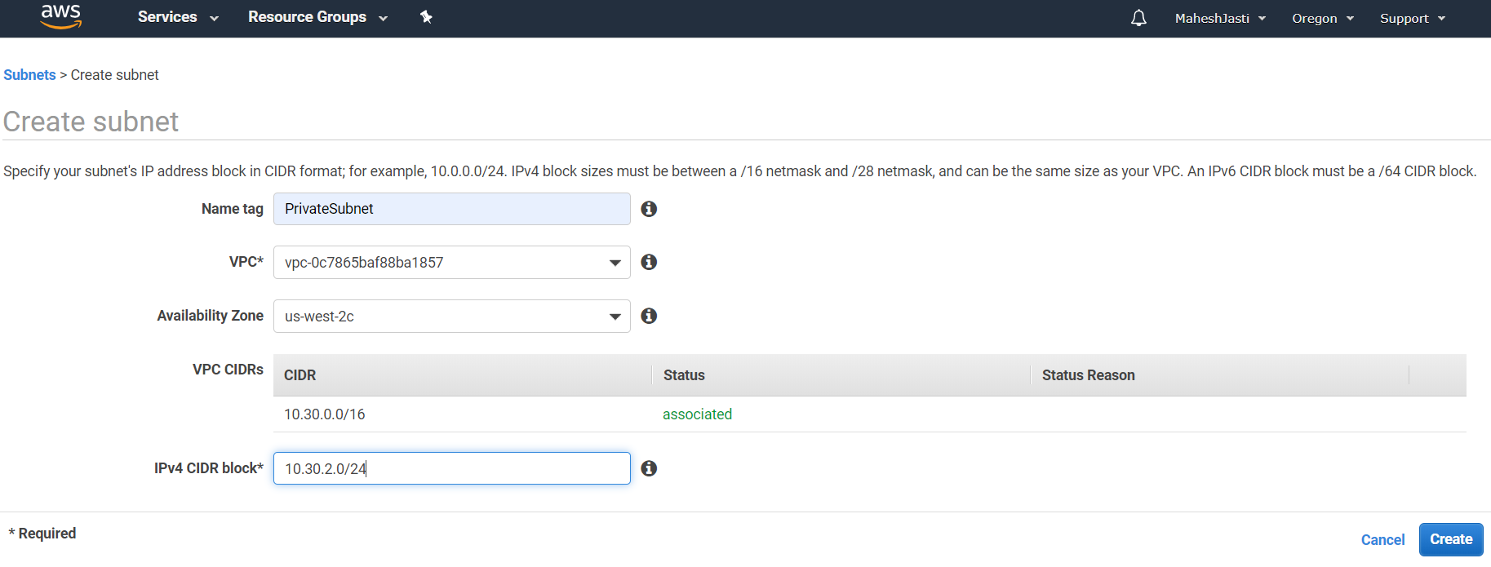

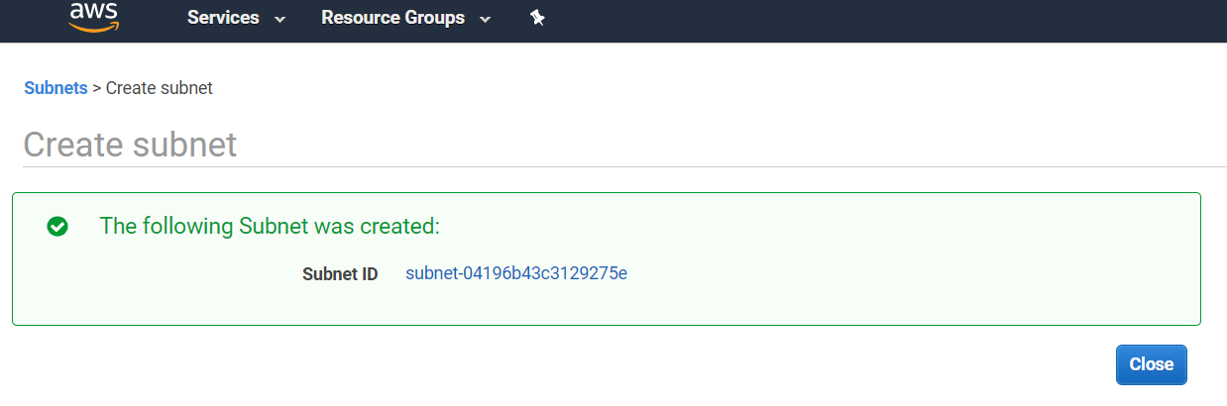

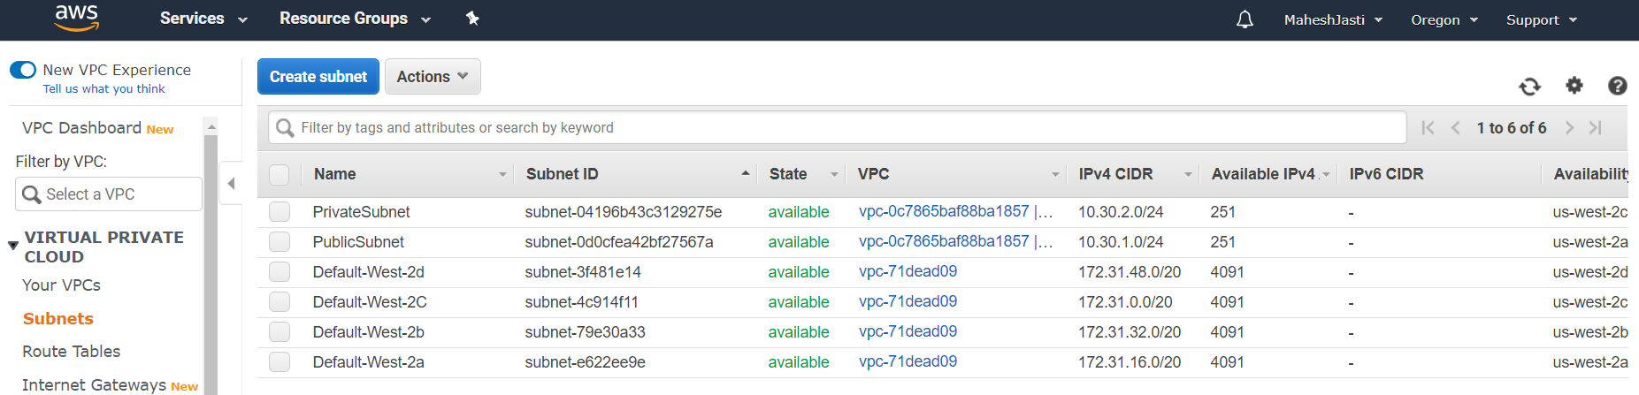

Both the Subnets has been created with 251 Available IPV4 addresses.

**Step#7**

Now select the “PublicSubnet” and go to actions and select the Modify auto-assign IP settings.

Enable Auto Assign public IPV4 Address for the “PublicSubnet” and click on Save. This will help to create the IP address automatically when EC2 instance created.

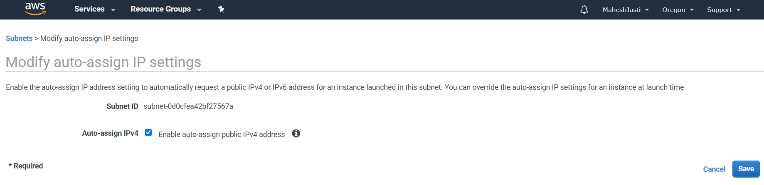

**Step#8**

Create an Internet Gateway. Click on the Internet Gateways option on the left menu.

Now click on “Create Internet Gateway” at top right side of the screen. Enter the name tag as “projectIGWY” and click on Create Internet Gateway button.

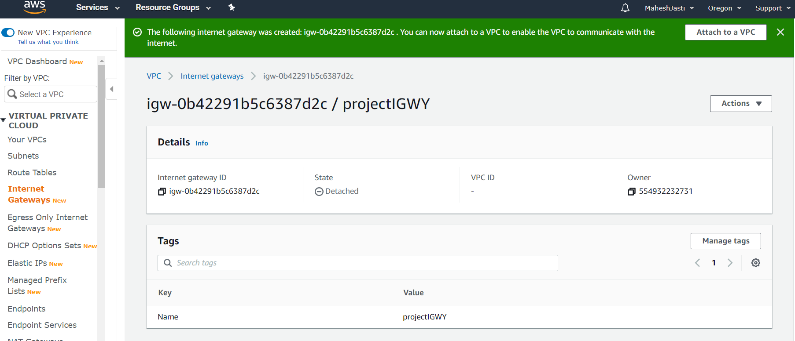

Now attach to the ProjectMattermost VPC by clicking at the button “Attach to a VPC”

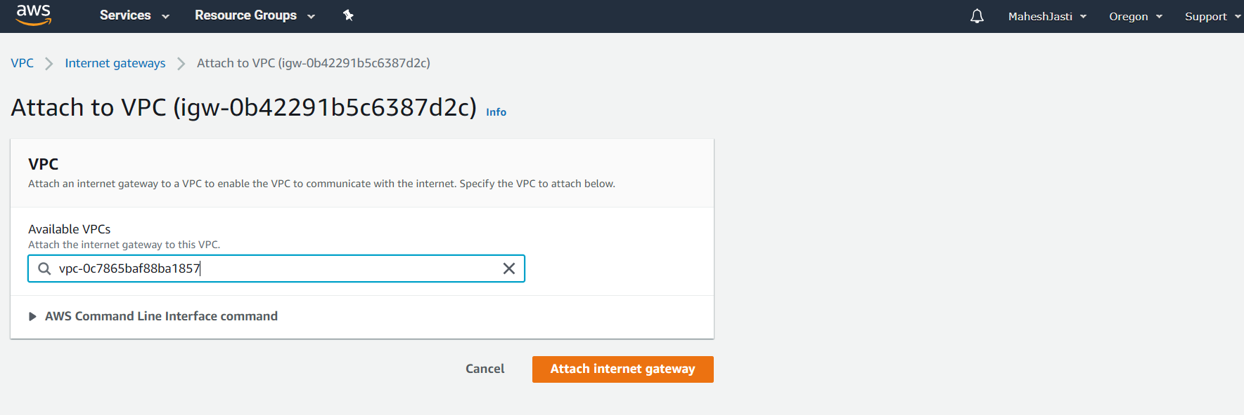

After attaching the IGWY we would see the following screen.

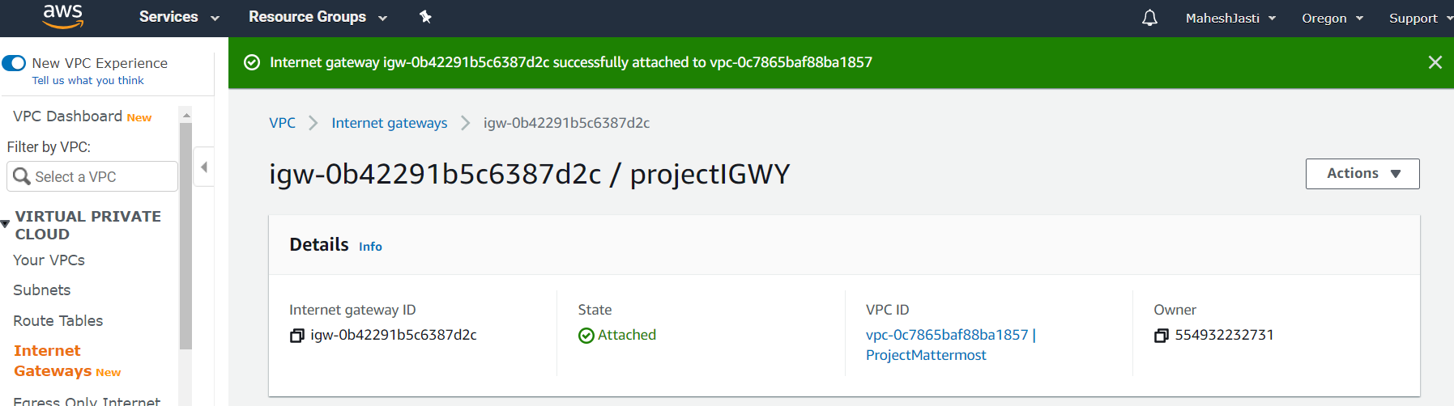

**Step#9**

Now create a new Route table(“projectmattermostRTtbl”) for the VPC by clicking on the Route Table option.

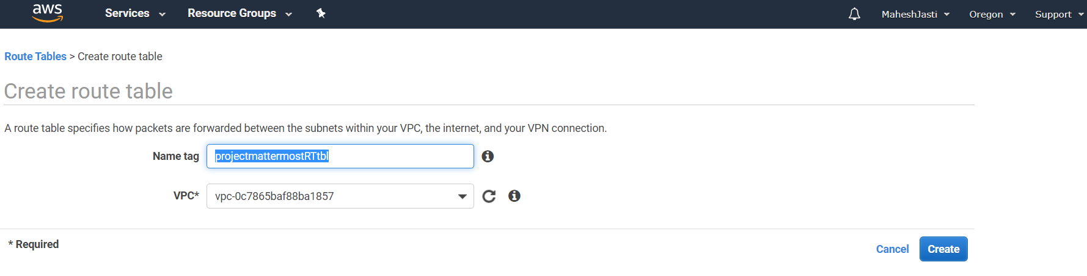

The route table is created and the “Main” attribute should show **“No”**

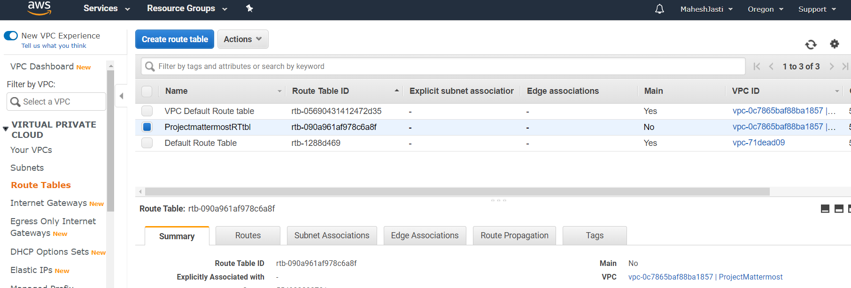

**Step#10**

Go to Routes tab and click on “Edit Routes” and add the Internet Gateway and click on Save routes button.

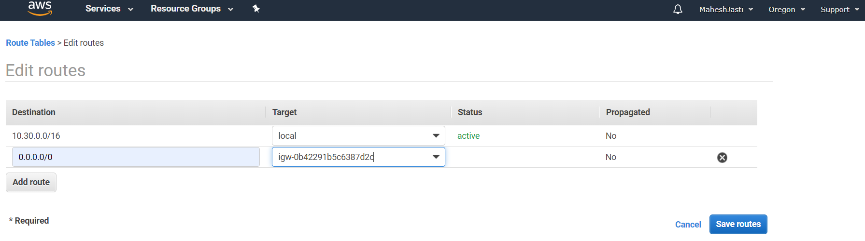

And should show as below after pressing the Save routes button.

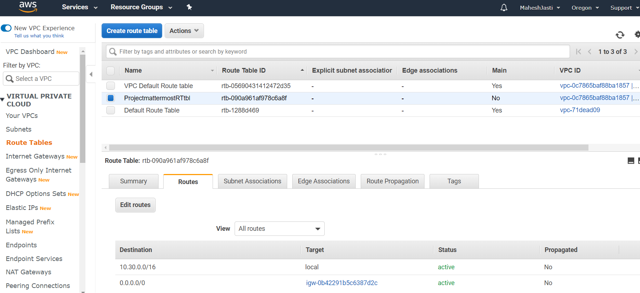

**Step#11**

Go to “Subnet Associations” tab and click on “Edit subnet associations” button and associate the PublicSubnet.

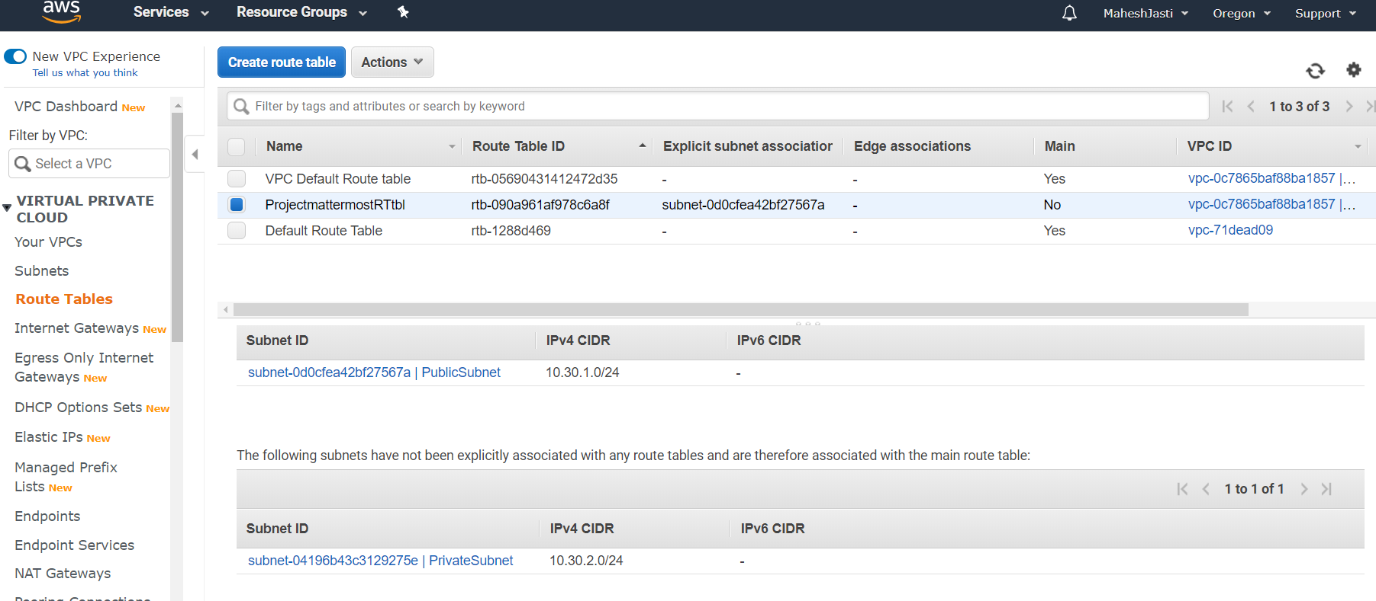

**********VPC, Subnets, IGWY and Route Tables setup is completed**********

**************Ubuntu EC2 and NAT Instances setup steps****************

Create 2 EC2 instances – (Ubuntu 18.04 LTS)

**Step#12**

Go to EC2 window, Click on Launch Instance

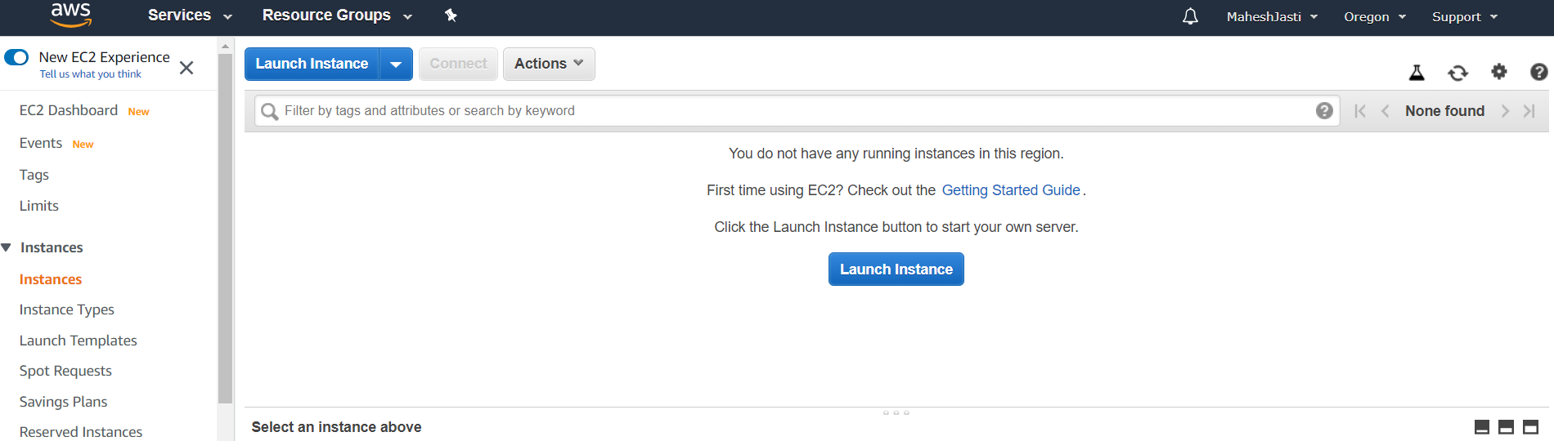

Select Ubuntu 18.04 LTS AMI

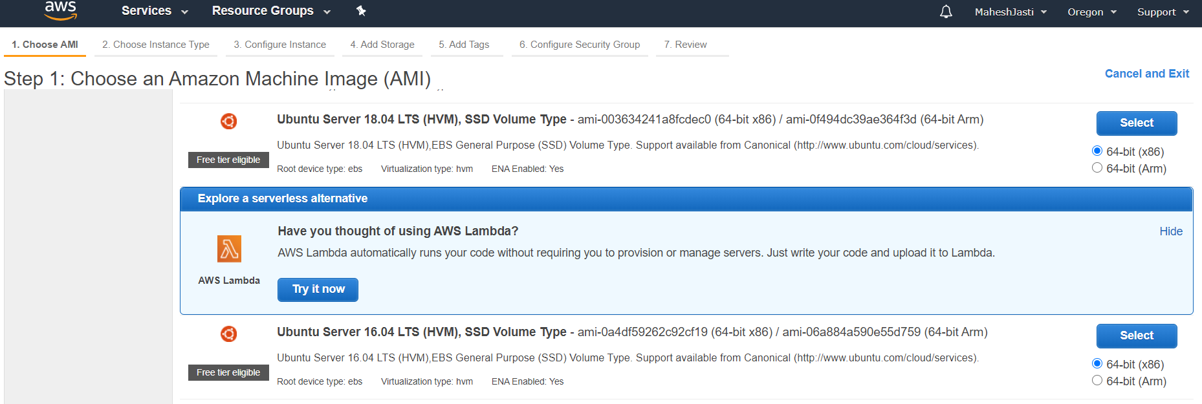

And select Ubuntu Server 18.04 LTS (FreeTier)

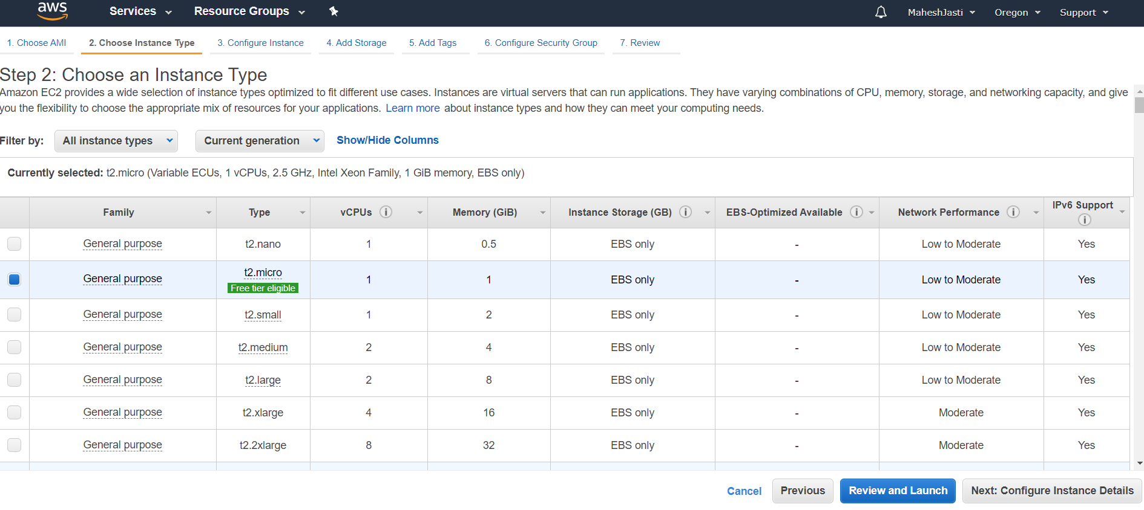

**Step#13**

Select the ProjectMattermost VPC and Public Subnet and click on Add Storage button below..

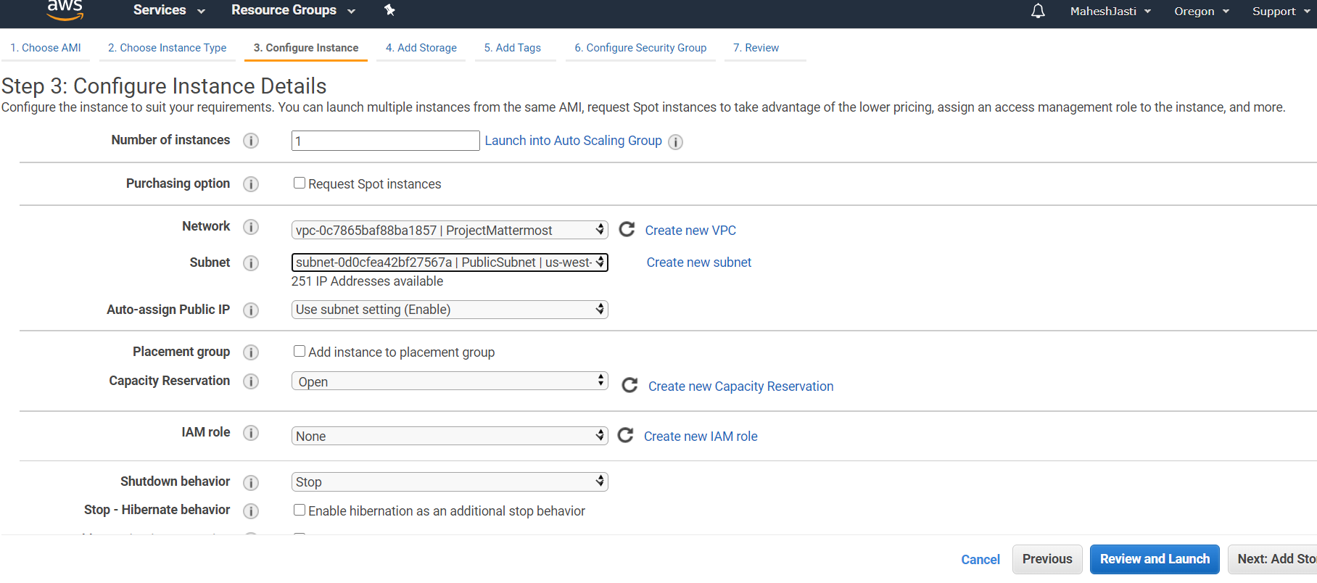

**Step#14**

No changes to Storage screen

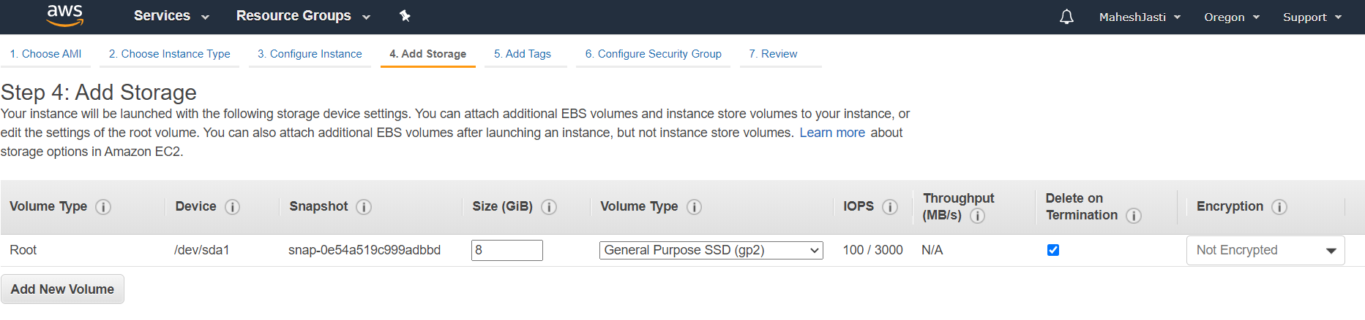

**Step#15**

Add the name tag as “App-Mattermost”

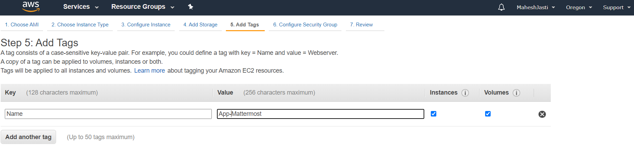

**Step#16**

Create a security group as below. Allow SSH and HTTP (as to install the software and access the application through outside). Click on “Review and Launch” button

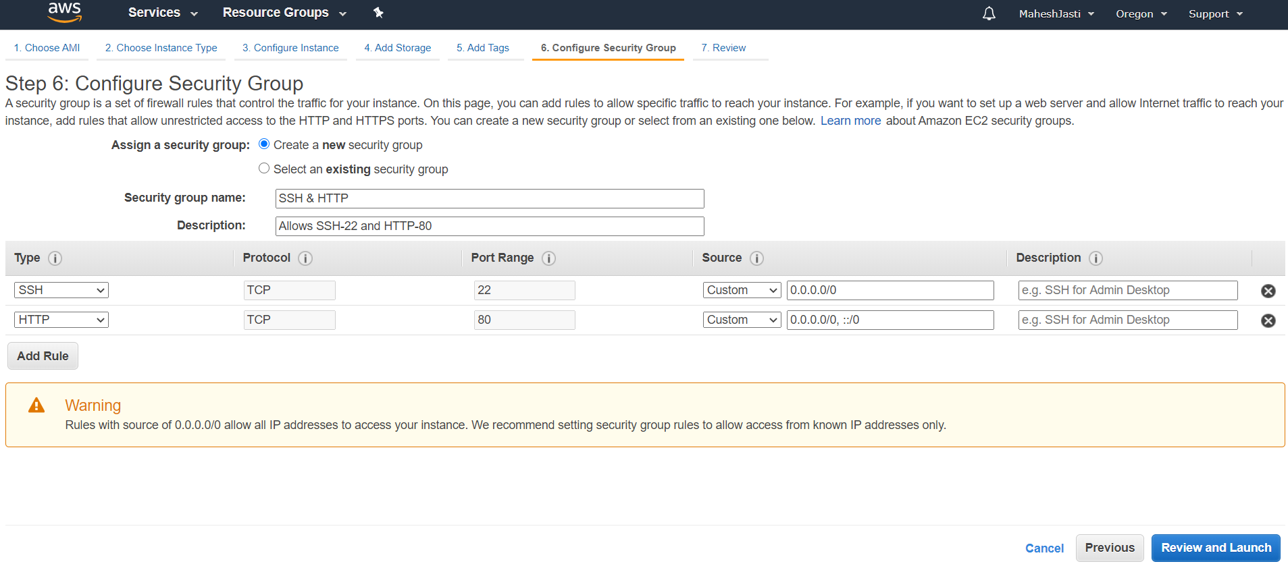

**Step#17**

And click on Launch button

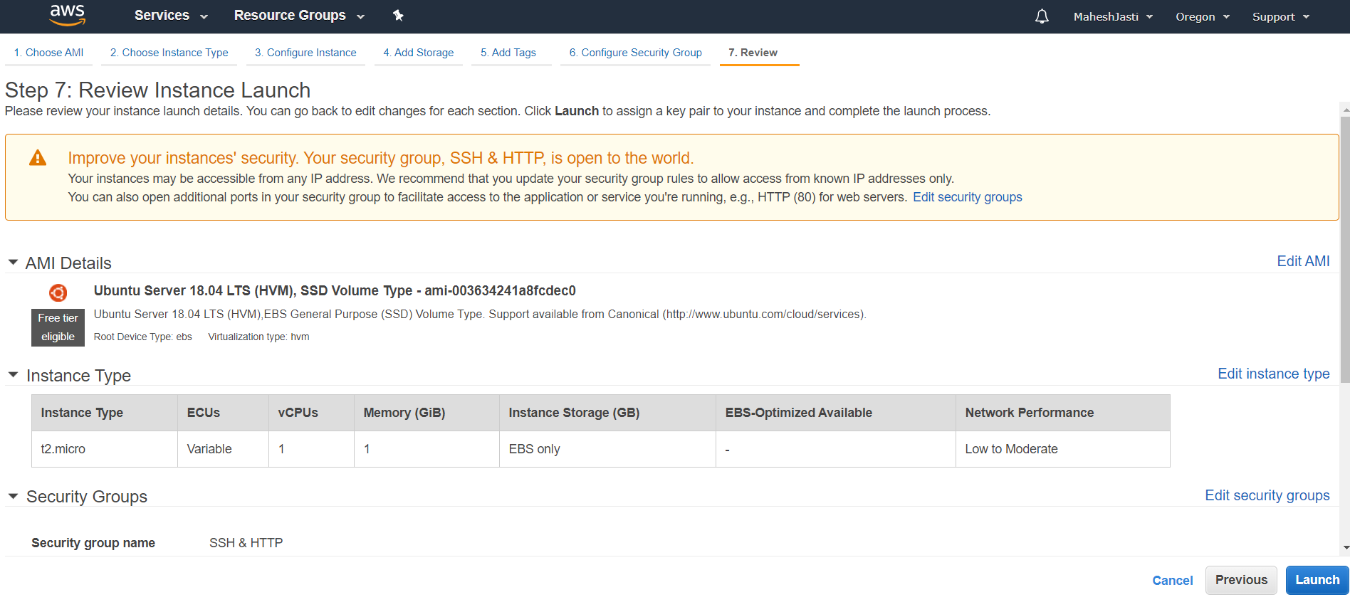

**Step#18**

Now Choose an existing Key Pair (VPCkeypair)… Acknowledge and Click on “Launch Instances”

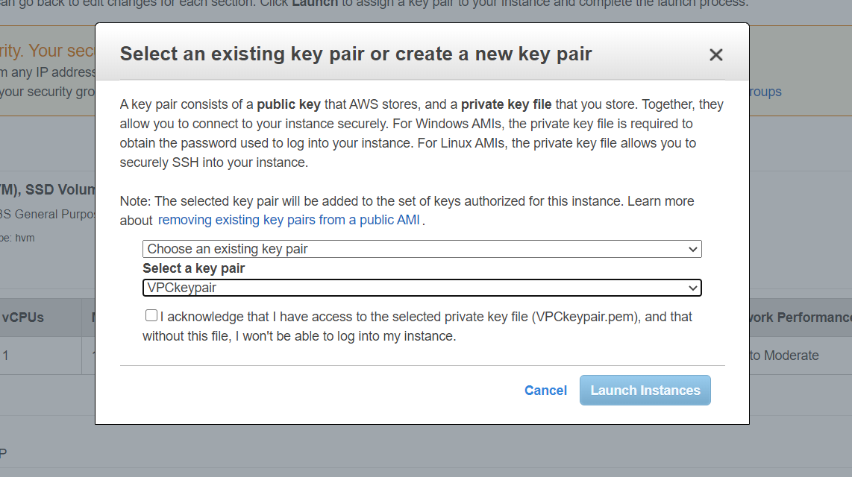

It will show like below.

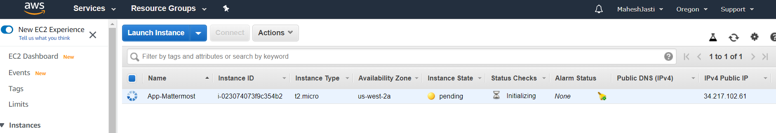

**Step#19**

The Public IP addr – 52.33.55.49 and the Private IP - 10.30.1.184 has been assigned.

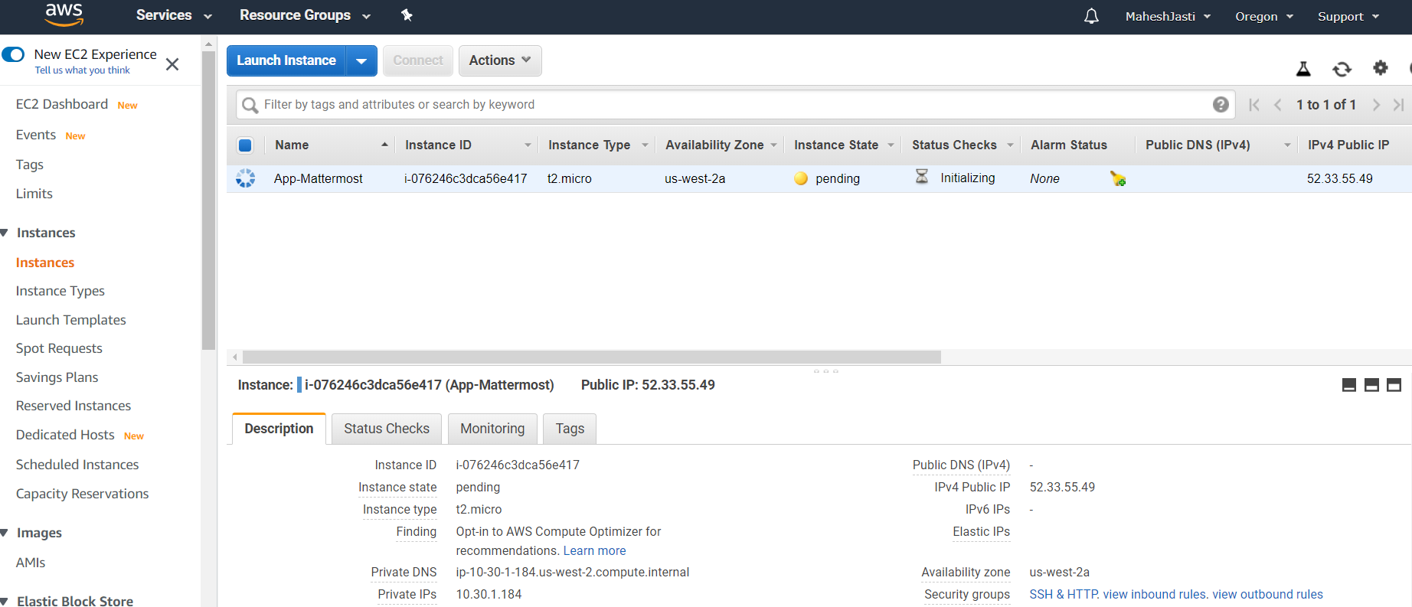

**Step#20**

Now launch the another Ubuntu EC2 instance and select the subnet “PrivateSubnet” (us-west-2c)

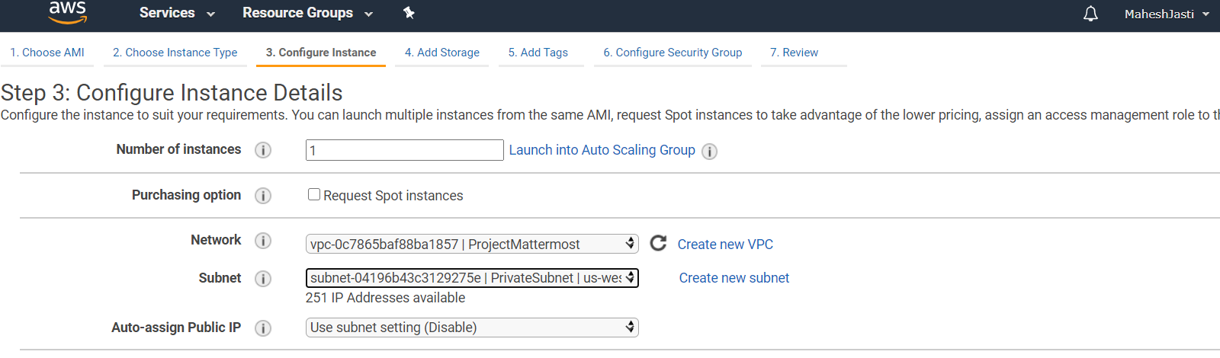

**Step#21**

No changes to the Add Storage screen

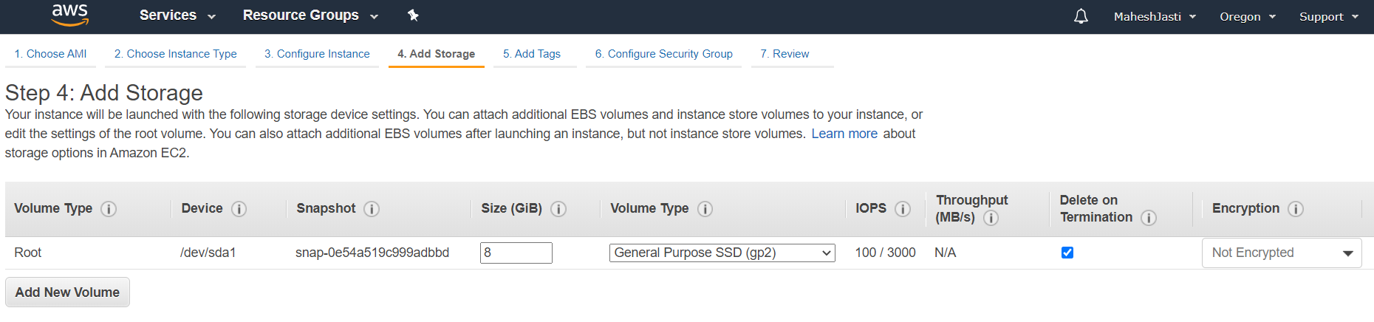

**Step#22**

and enter the name tag as “DB-MySql”

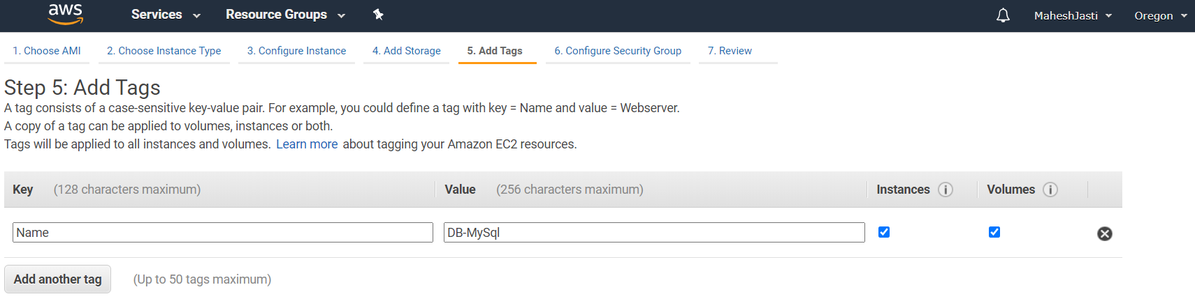

**Step#23**

Select existing Security group – mysqlprivate

We want to restrict the access to the private subnet, Hence we are restricting the access to only public CIDR’s

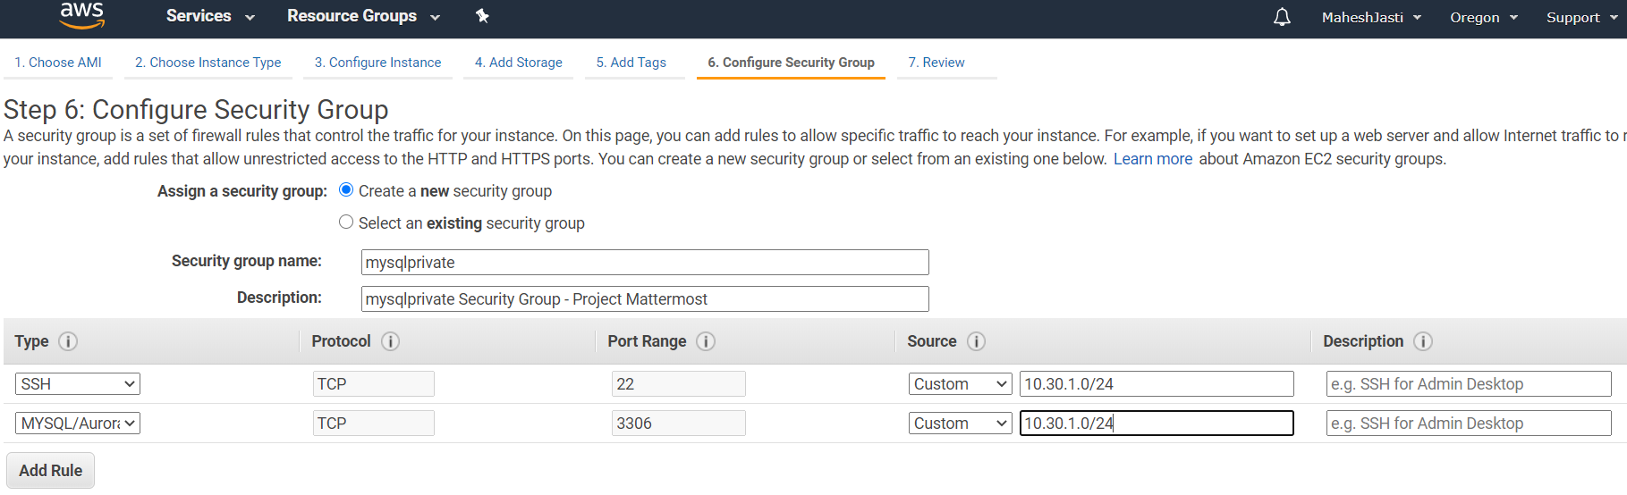

**Step#24**

Click on Launch

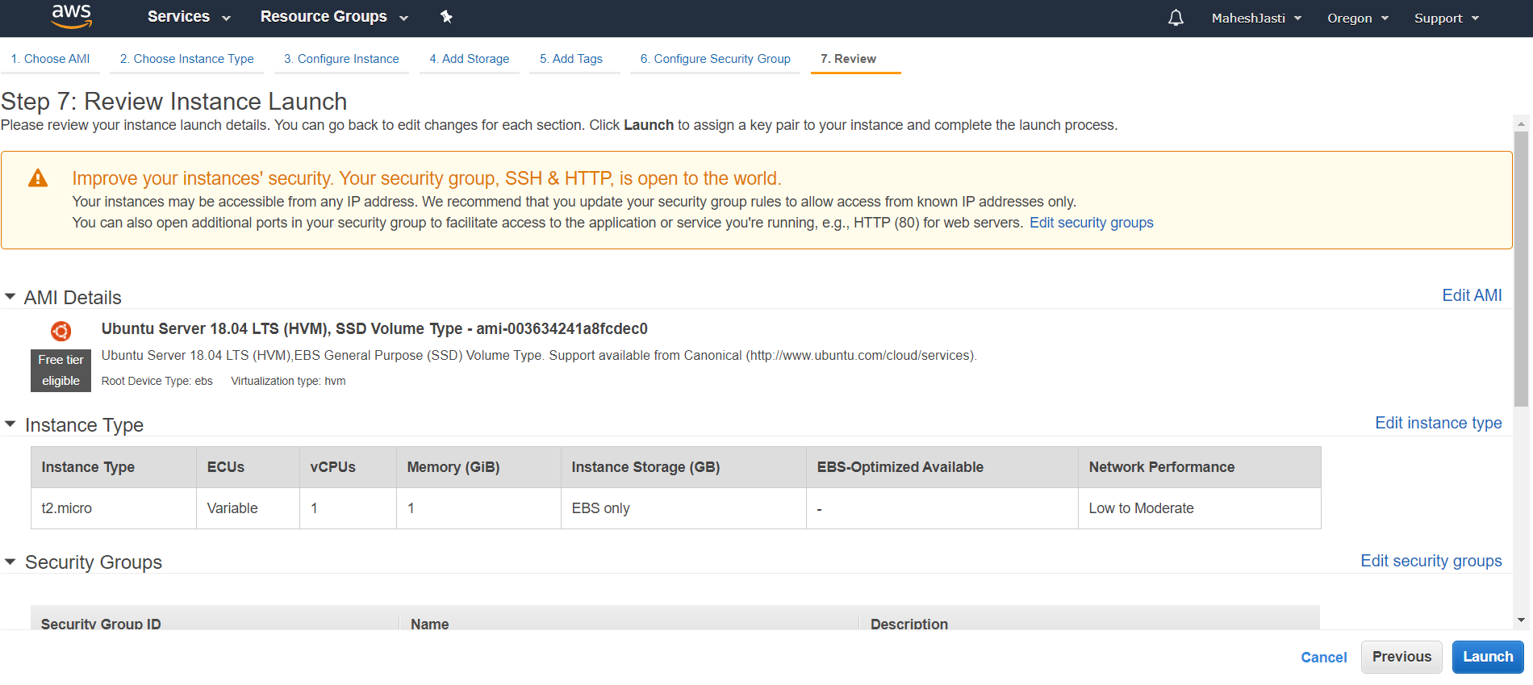

**Step#25**

Now choose an existing key pair and click on Launch Instances.

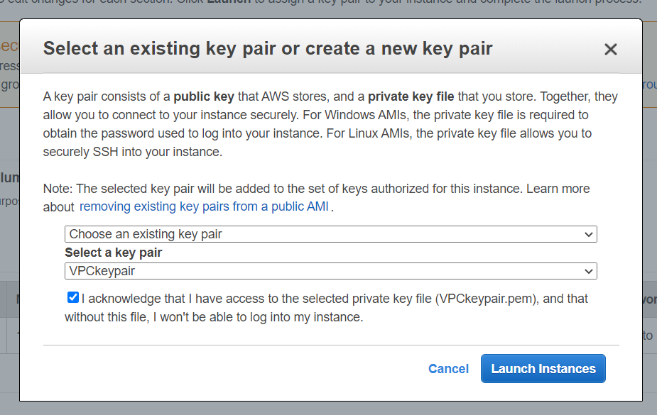

**Step#26**

The DB-MySQL instance didn’t get the public IPV4 address as we haven’t enabled the Auto Assign IPV4 Address for the Private Subnet. (Private IP: 10.30.2.225)

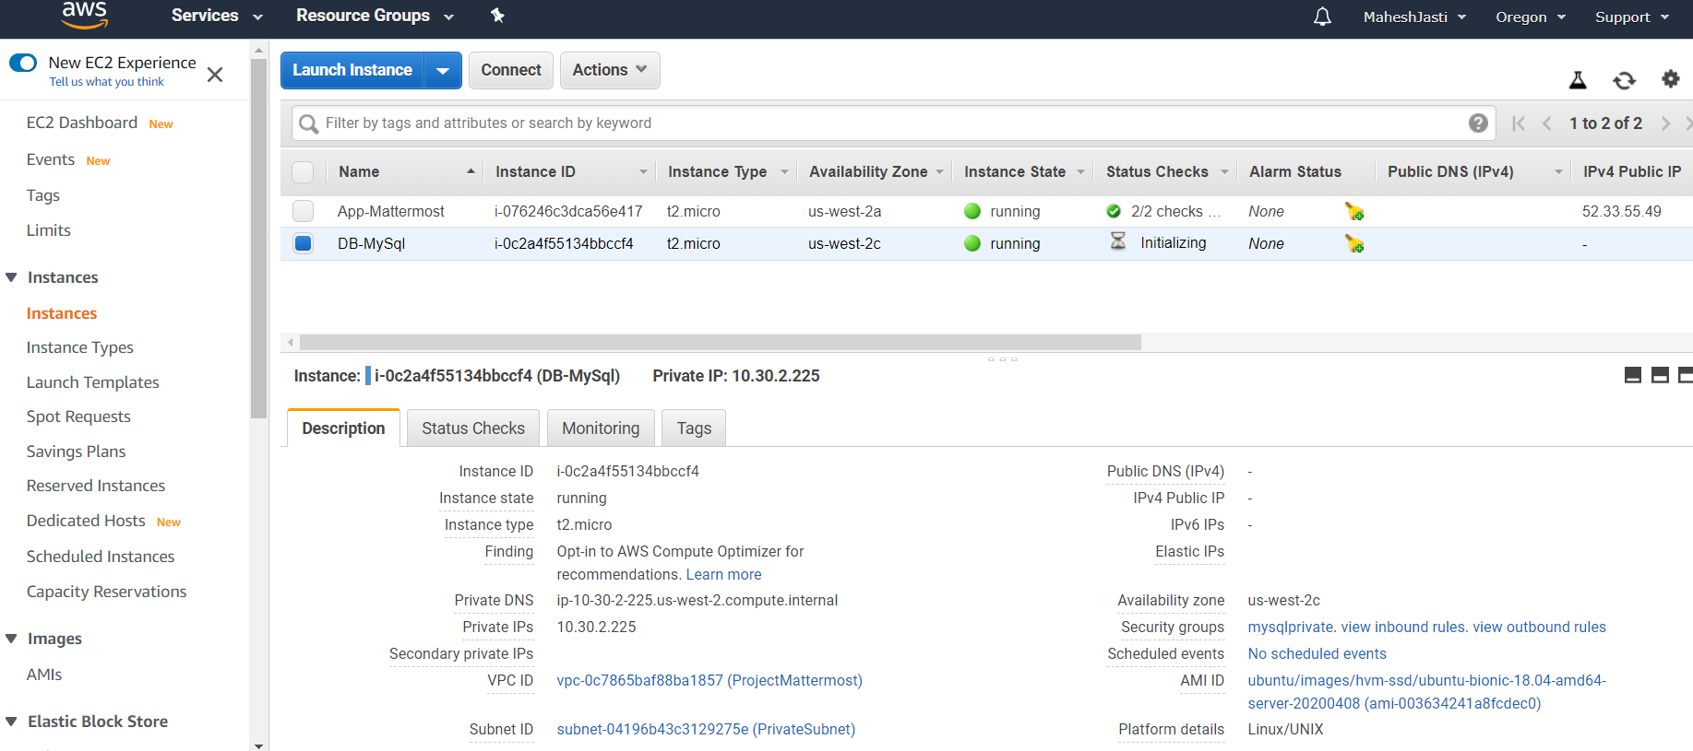

**Step#27**

Create a NAT Instance in the PublicSubnet and link to the Private Subnet in the Route table.

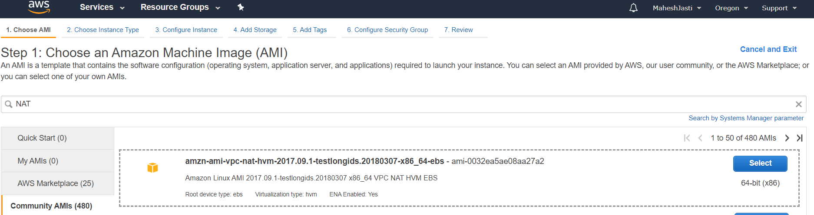

**Step#28**

Select default T2 Micro and select the VPC ProjectMattermost and PublicSubnet.

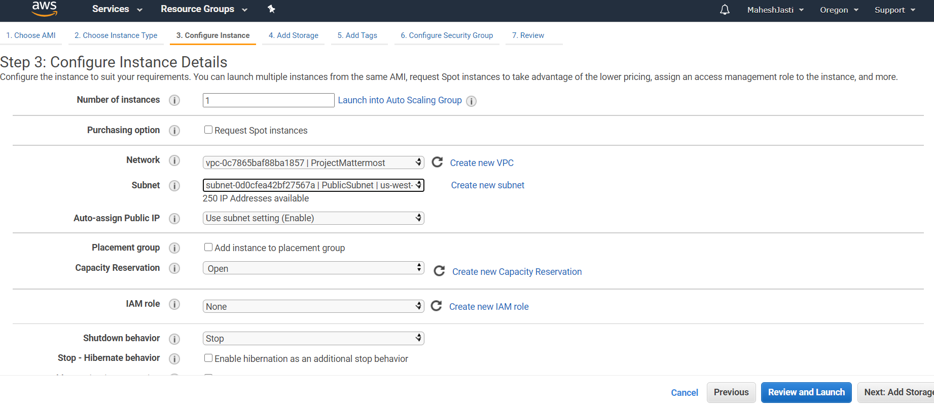

**Step#29**

No changes to Add Storage screen..

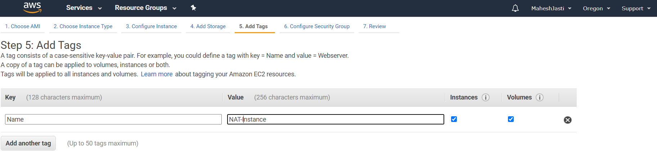

**Step#30**

Select the existing Security Group (SSH & HTTP) and launch the instance.

**Note:** Since it is a NAT instance, we won’t login, access or install any software. No need to think about the Security Group and their rules.

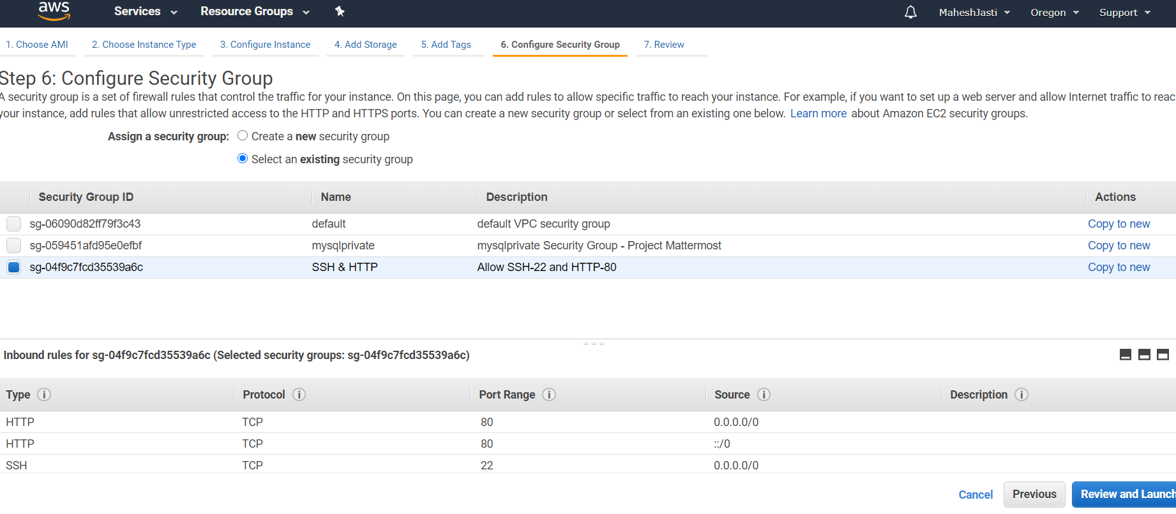

**Step#31**

Since we won’t be logging in or installing into NAT, no need to select any key pair.

And select the drop down values as “Proceed without a key pair”, Acknowledge and click on Launch Instances.

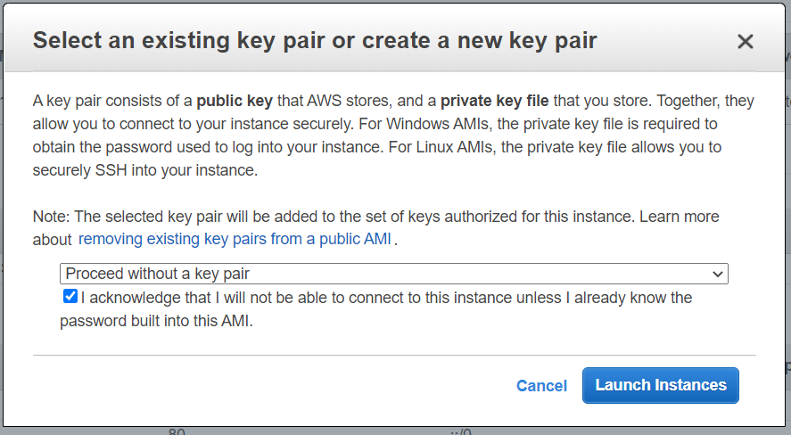

Now NAT instance has been created (Public IP 54.70.203.137 ; Private IP: 10.30.1.239)

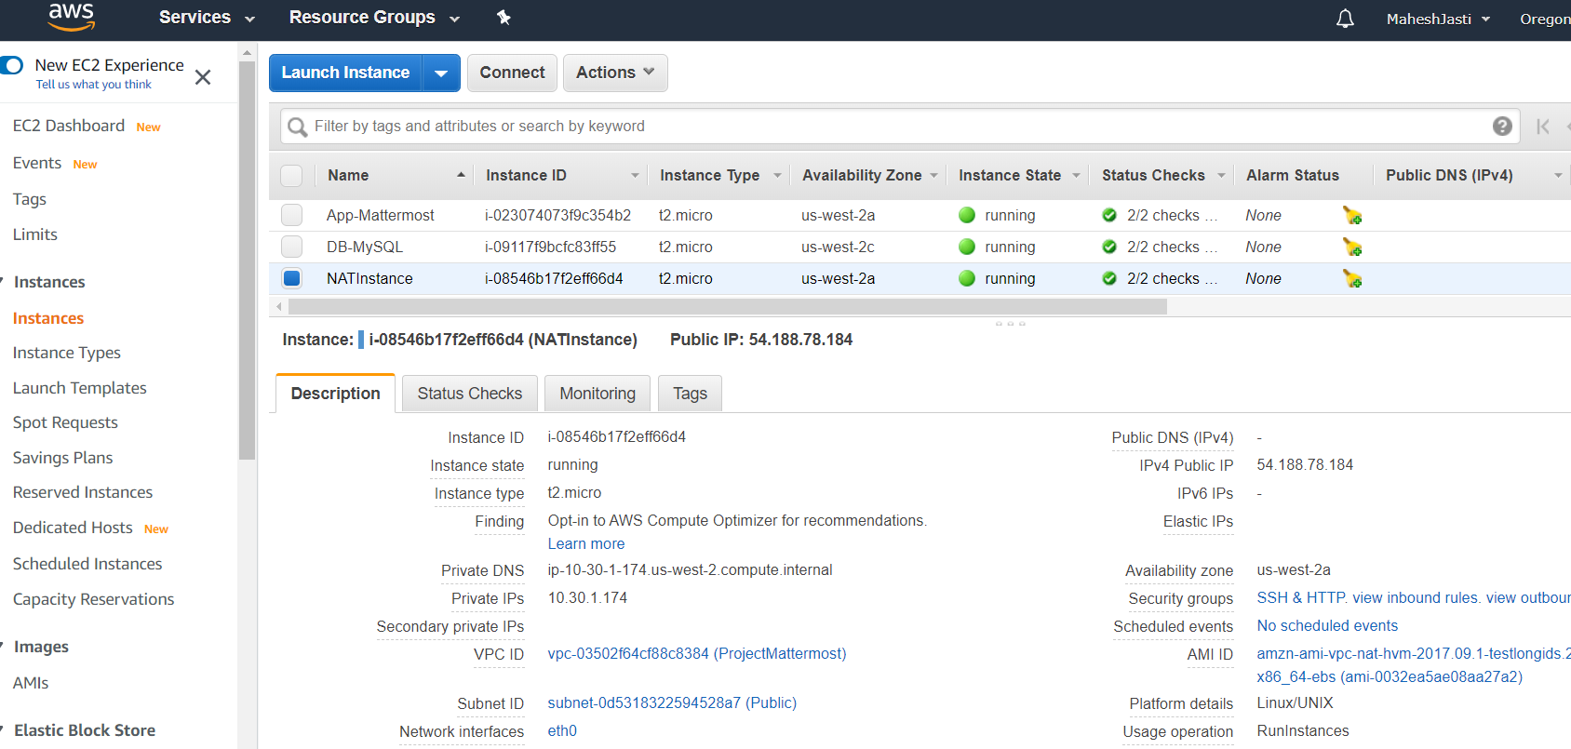

**Step#32**

Now Disable the Change Source/Dest. Check for the NAT Instance..

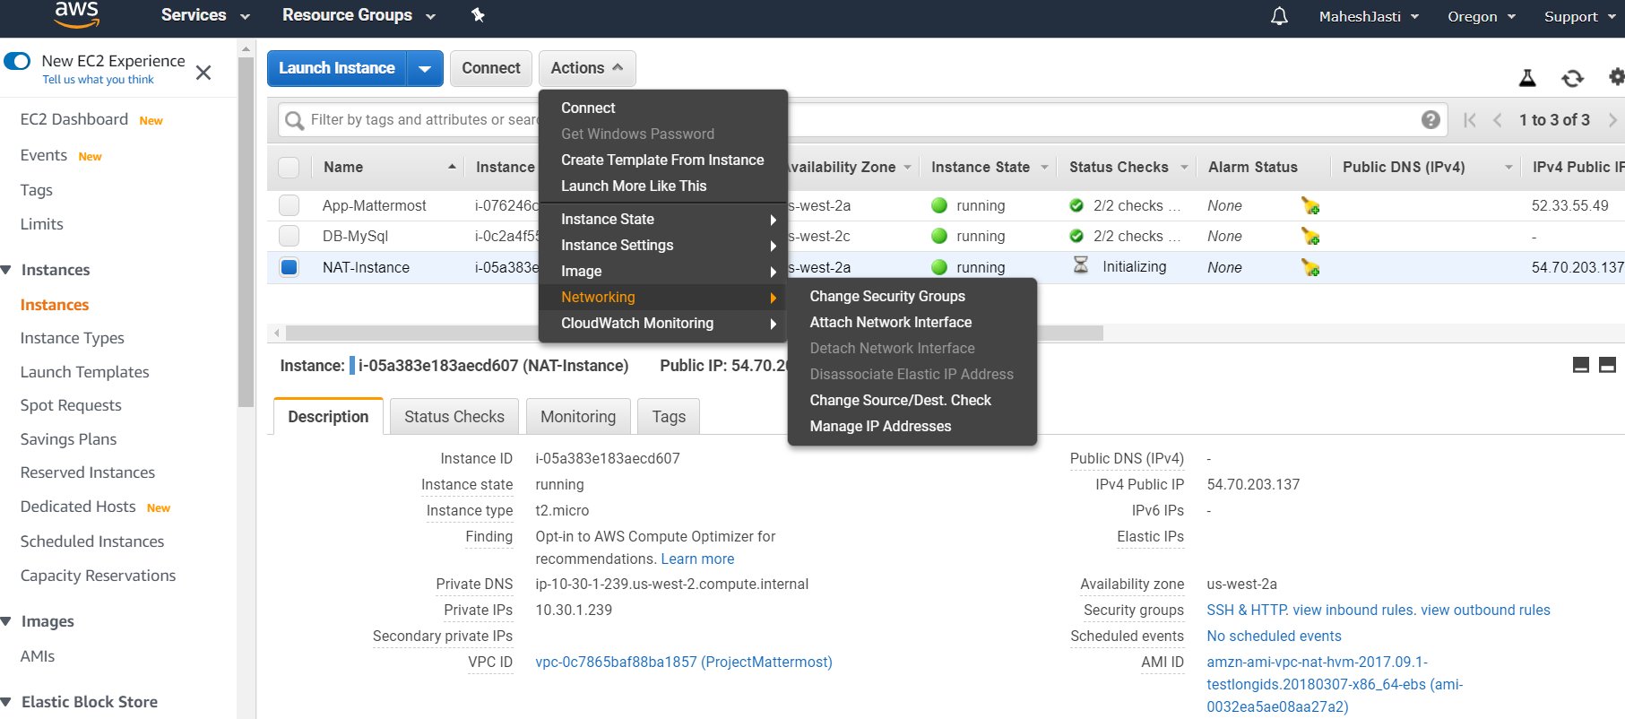

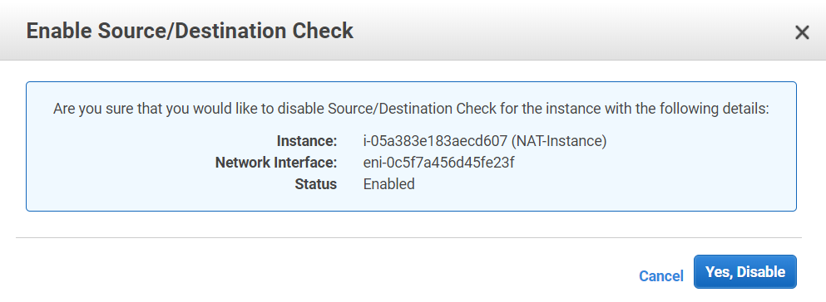

**************Ubuntu EC2 and NAT Instances setup done*****************

***************Route table setup for PrivateSubnet steps*****************

**Step#33**

Go to the Route Tables and create a new route table Natinstance-RT Table-Private and map to the PrivateSubnet.

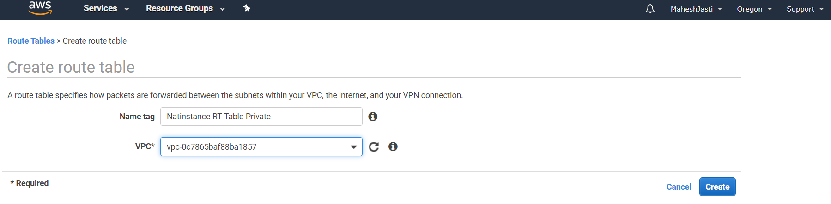

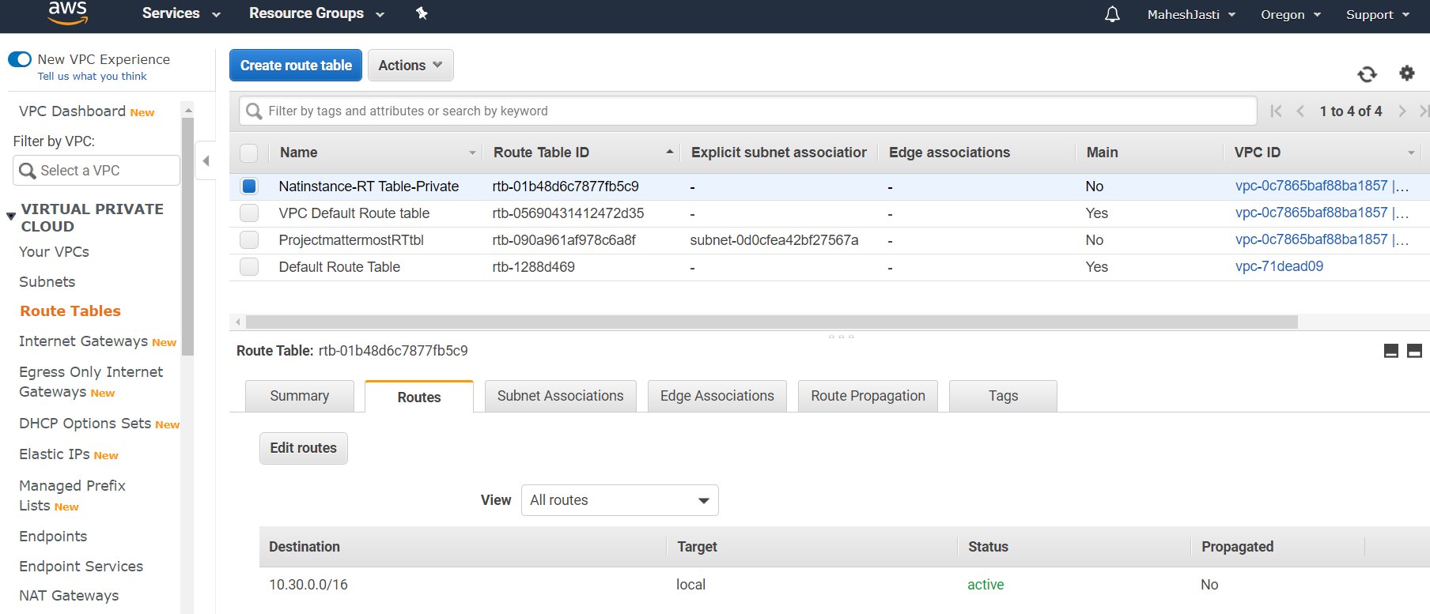

**Step#34**

Click on Edit routes and Add route as below and map the target as NAT Instance and click on Save routes.

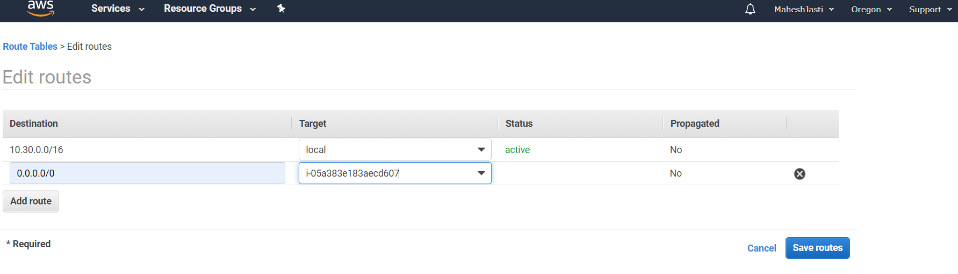

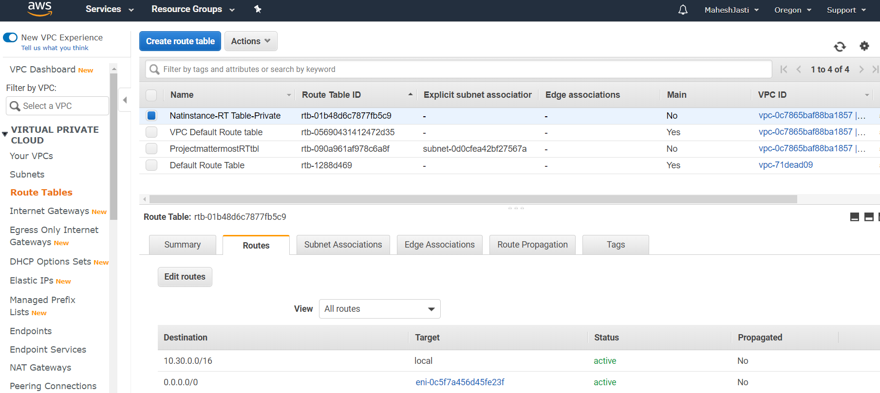

**Step#35**

Associate the PrivateSubnet in Edit subnet associations tab and click on Save button

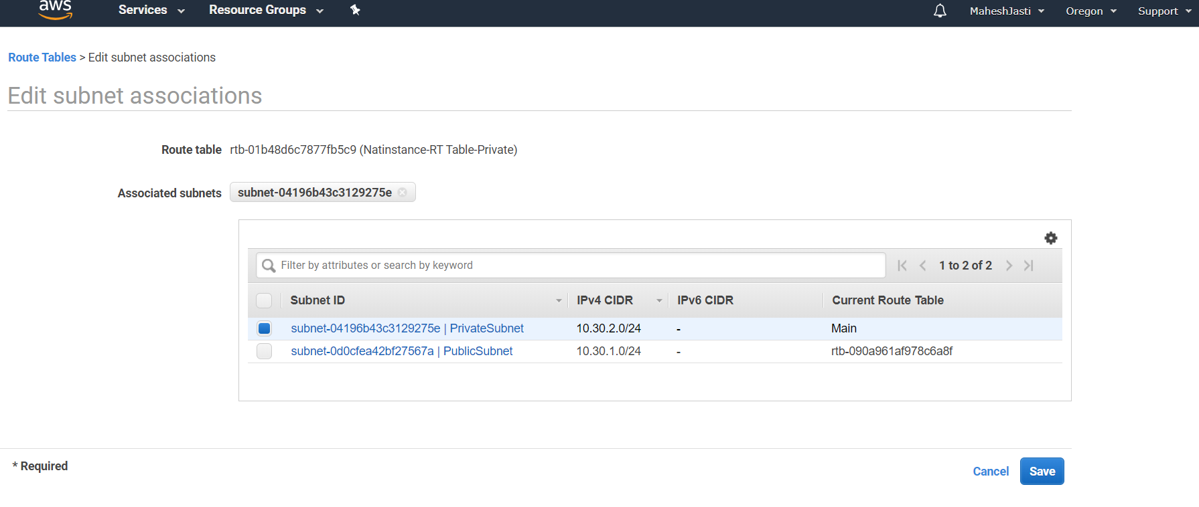

Subnet ID associated after clicking on the Save button

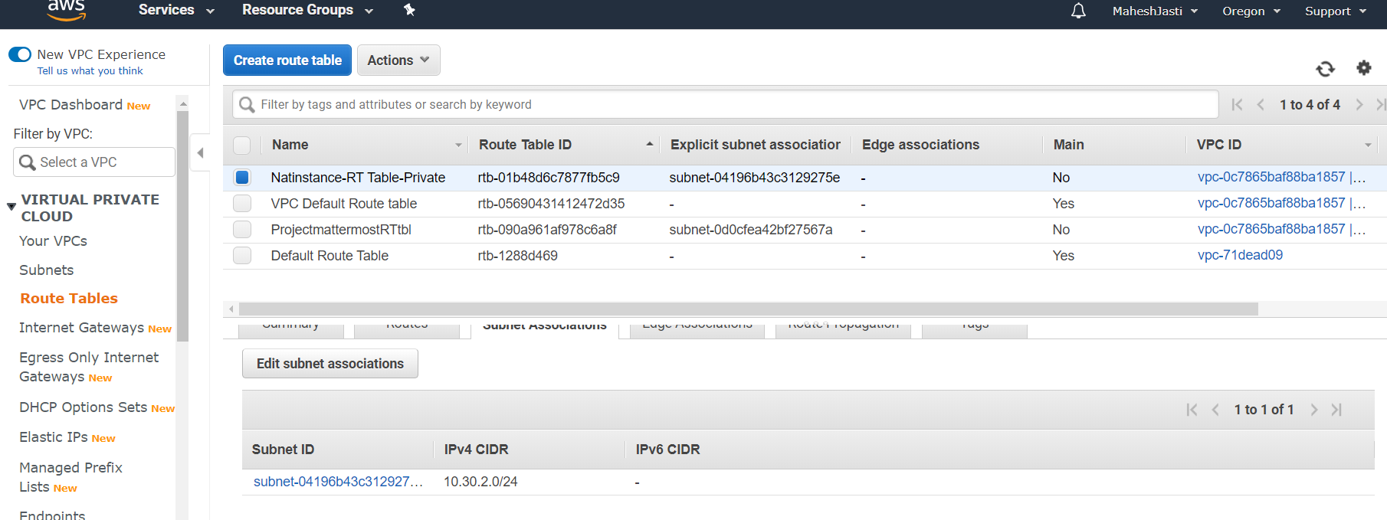

***********Route table setup for PrivateSubnet setup done****************

****Login into the EC2 instances – Access check b/n Public and Private *****

**Step#36**

Until this we have setup IGWY to Public Subnet and NAT Instance to the Private Subnet.

Now login to the Public Instance thru Putty – ubuntu@52.33.55.49

10.30.1.184

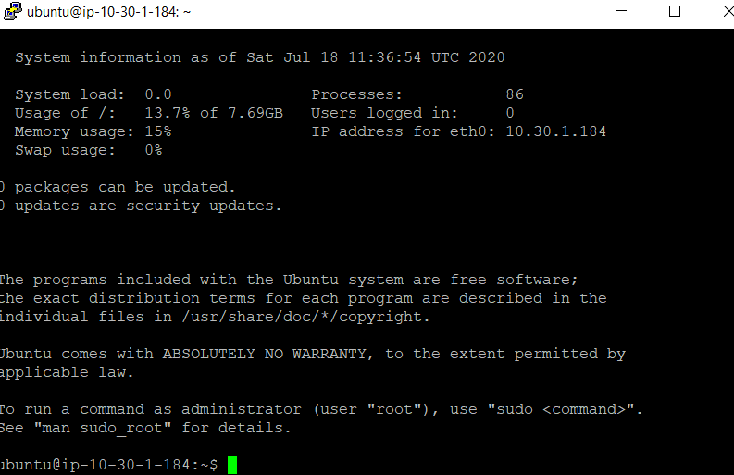

**Step#37**

We need to login to the 10.30.2.225 Private instance to install the MySQL Server. So we need to SSH from 10.30.1.184. We need the key to login. So create a key file(vpckeypair) and change the permissions of the file to Read only and execute the following commands

sudo nano vpckeypair

sudo chmod 400 vpckeypair

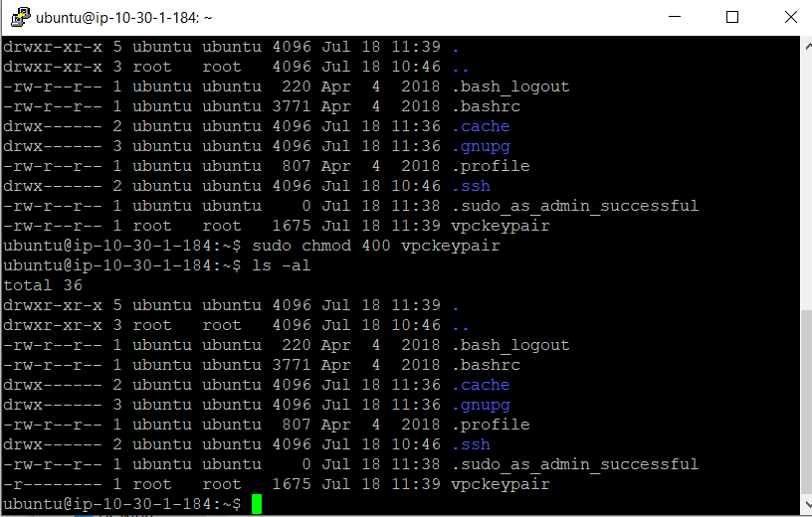

**Step#38**

Execute the following command to move to Private instance

sudo ssh -i vpckeypair [ubuntu@10.30.2.225](mailto:ubuntu@10.30.2.225)

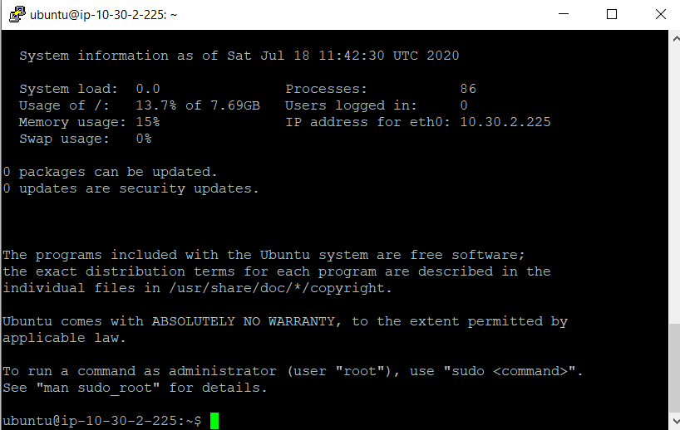

**Step#39**

You are into Ubuntu machine (Private Subnet) and execute the following 2 below commands..

sudo apt update and sudo apt upgrade (if you don’t upgrade, you will have some problems in installing MySql-Server)

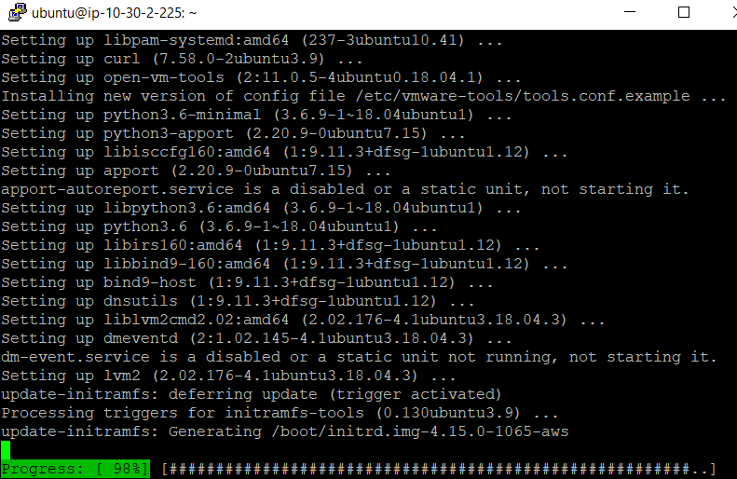

****************EC2 instances – Access check - Completed ****************

********Installation of Mysql & Mattermost softwares – Setup steps**********

**Step#40**

Install MySQL Server. Use the following command to install.

sudo apt install mysql-server

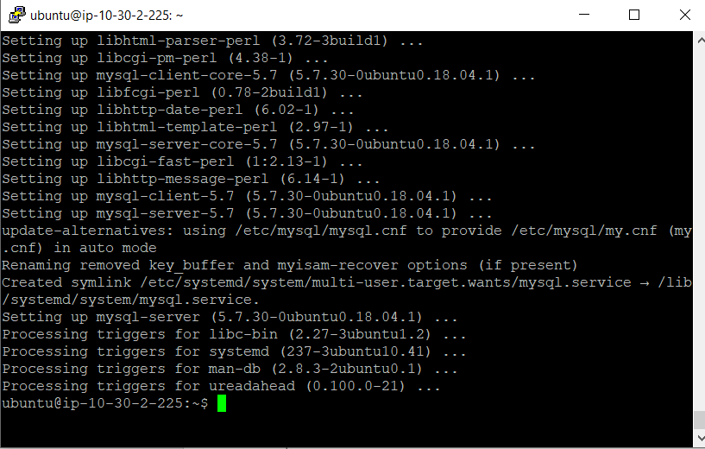

**Step#41**

Running mysql_secure_installation – To check the password settings and setup root password and admin settings.

sudo mysql_secure_installation (sudo – should be in small letters)

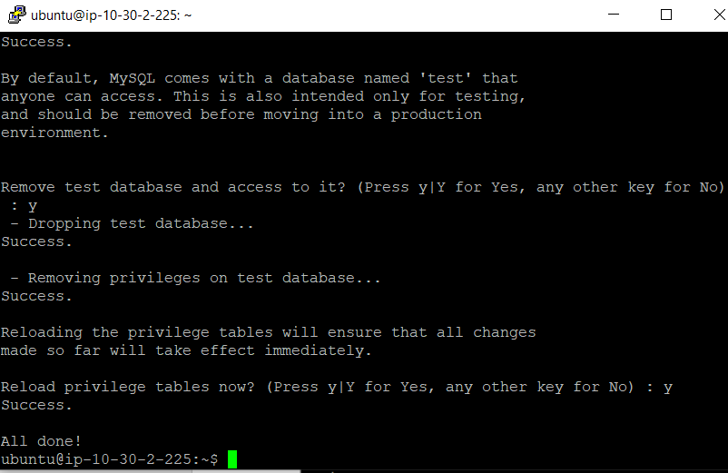

**Step#42**

sudo mysql

Created an User and the password and also set only the public subnet which has the mattermost app to access the MySQL which is in private subnet.

create user 'mmuser'@'%' identified by 'maheshjast';

create database mattermost;

GRANT ALTER, CREATE, DELETE, DROP, INDEX, INSERT, SELECT, UPDATE ON mattermost.* TO 'mmuser'@'%';

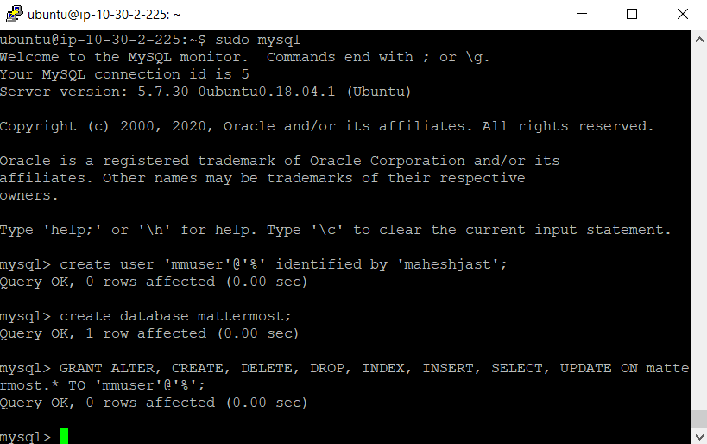

**Step#43**

Exit mysql

sudo nano /etc/mysql/mysql.conf.d/mysqld.cnf

Comment the bind-address 127.0.0.1

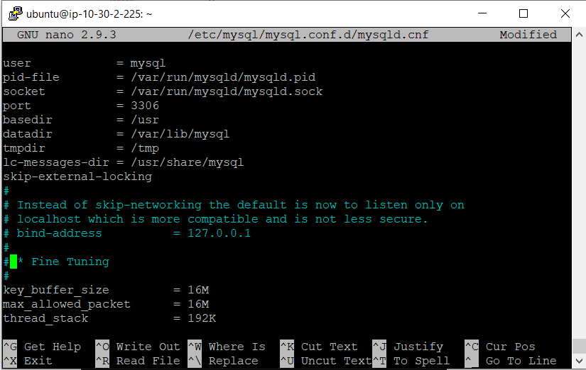

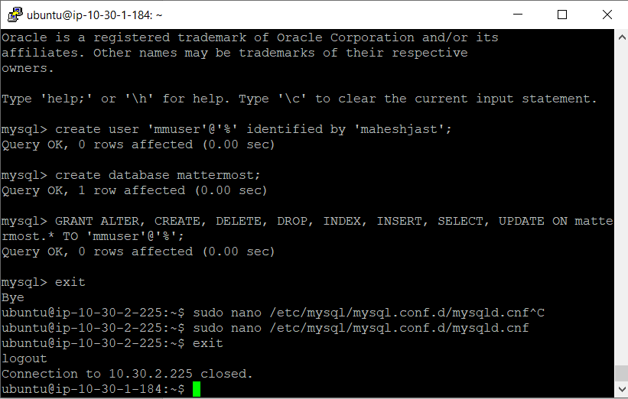

**Step#44**

Exit the private instance and install the mattermost in the public instance by using the following command

sudo apt update and sudo apt upgrade

wget <https://releases.mattermost.com/5.24.2/mattermost-5.24.2-linux-amd64.tar.gz>

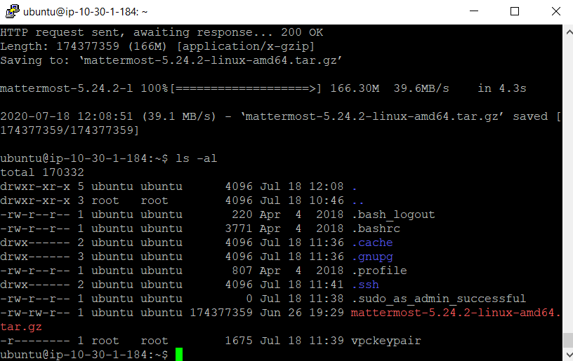

**Step#45**

And follow the commands to configure the Mattermost application….

tar -xvzf mattermost*.gz

sudo mv mattermost /opt

sudo mkdir /opt/mattermost/data

sudo useradd --system --user-group mattermost

sudo chown -R mattermost:mattermost /opt/mattermost

sudo chmod -R g+w /opt/mattermost

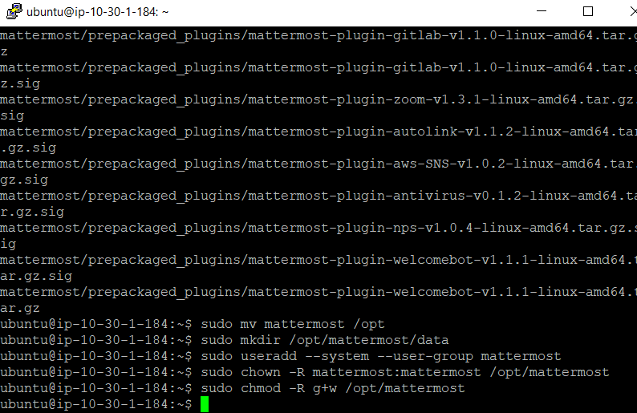

**Step#46**

Setup the database drive and update the datasource details with the user details that has been created for mysql

sudo nano /opt/mattermost/config/config.json

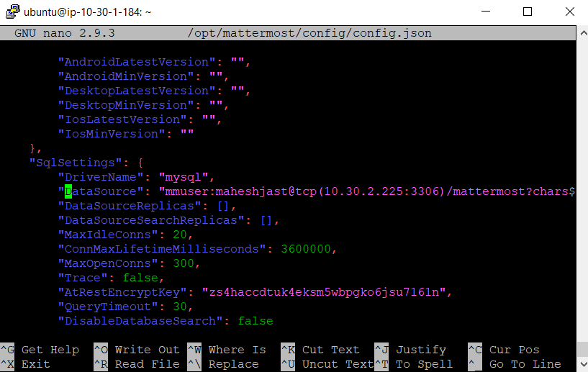

**Step#47**

Execute the following commands to setup the mattermost service

cd /opt/mattermost

sudo -u mattermost ./bin/mattermost

sudo nano /lib/systemd/system/mattermost.service (update the file as per the comments)

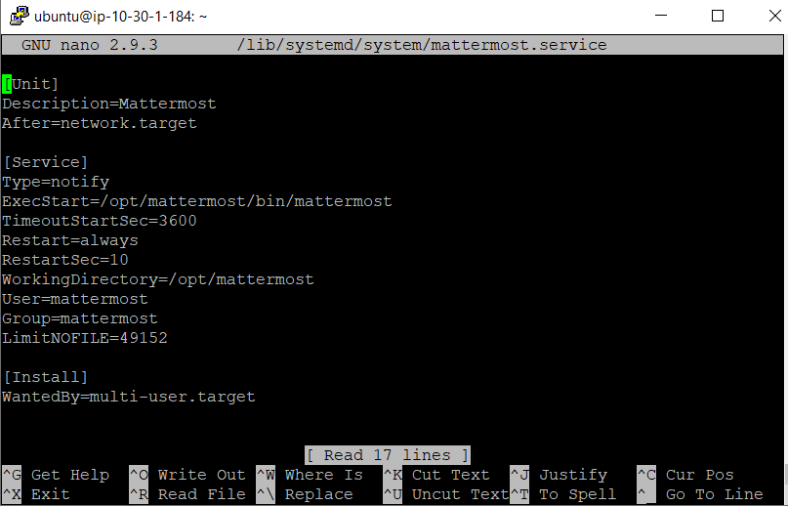

sudo systemctl daemon-reload

sudo systemctl status mattermost.service

sudo systemctl start mattermost.service

sudo systemctl enable mattermost.service

**Step#47**

Now update the security group for App-mattermost instance with the following

Open the TCP for the port 8065. This is very important step.

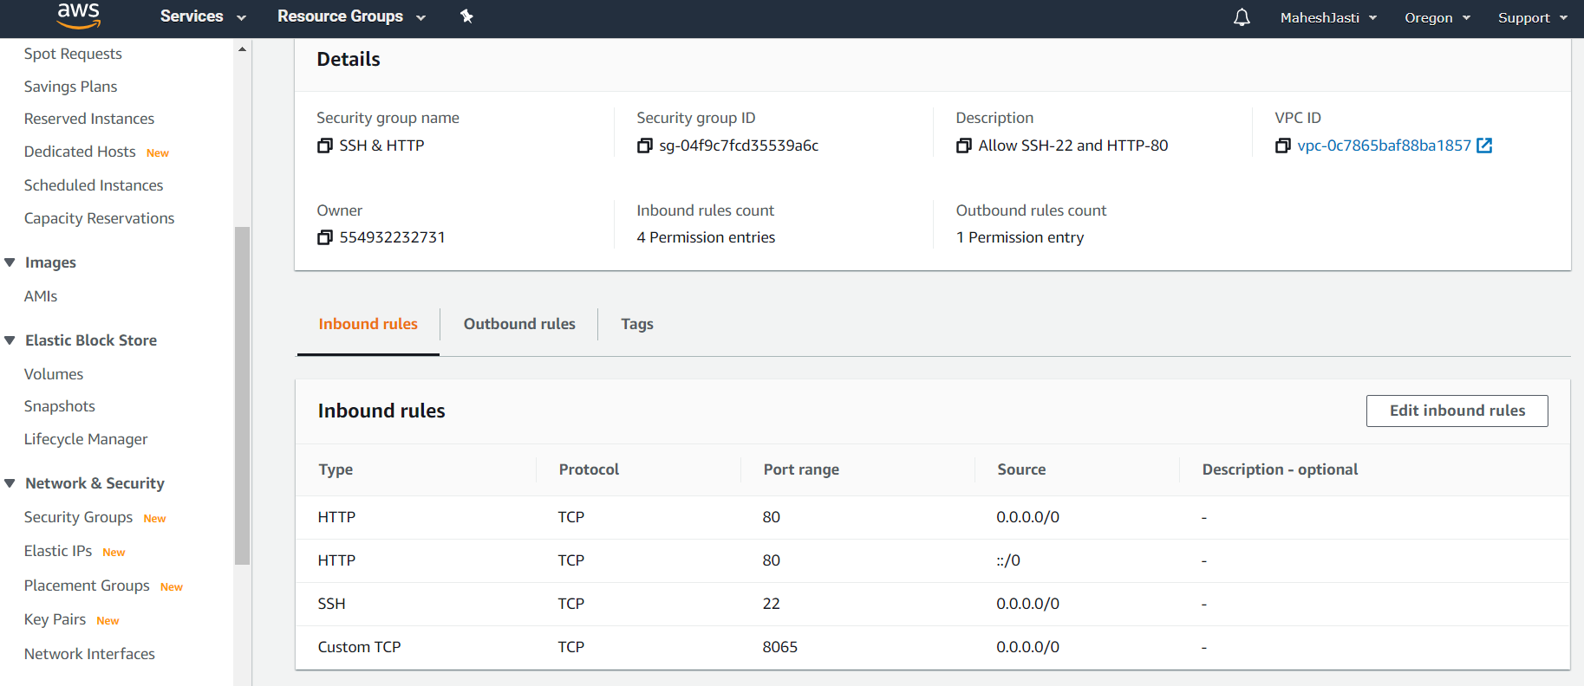

**Step#48**

Now open a browser and go to <http://52.33.55.49:8065/>

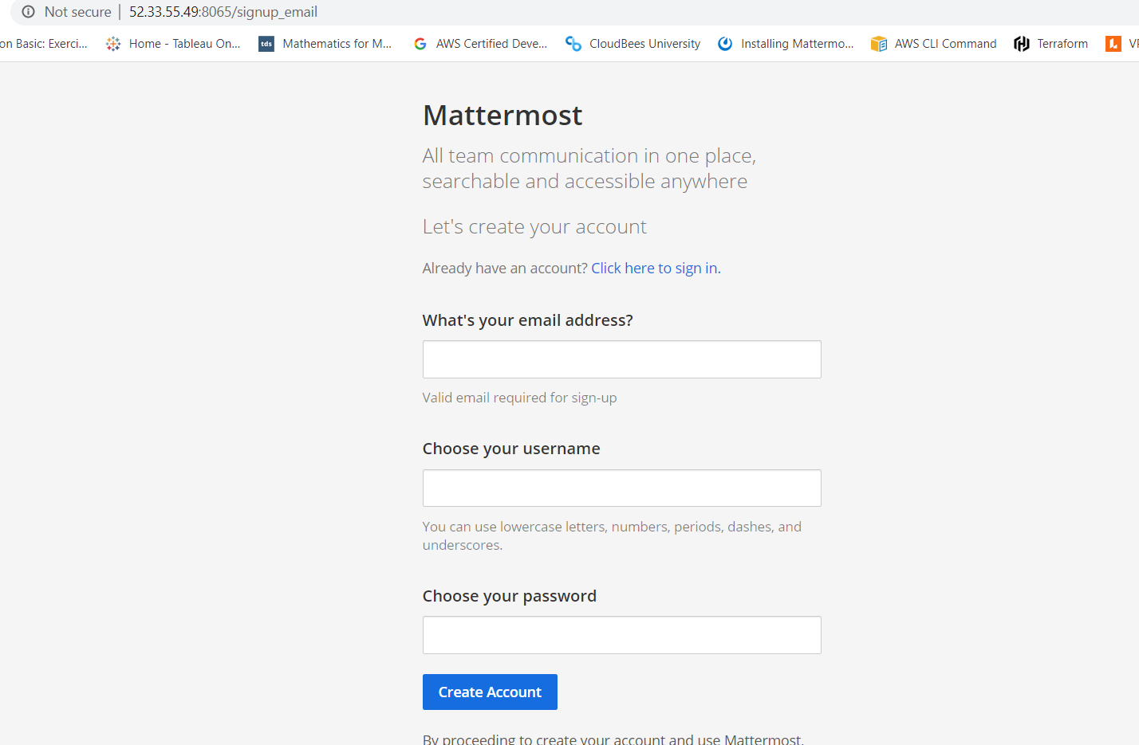

*******Installation of Mysql & Mattermost softwares – Setup completed******